Fall 2021 End of Semester Report
Sophie Impellitteri, Jan 13, 2022
The Fall 2021 semester was refreshing after over a year of almost entirely virtual Eco Rep programming. The Eco Reps were much closer as a group, which made the work more fun and enjoyable. At the same time, many Reps expressed frustration with both the program’s overarching approach to environmentalism and the lack of participation with our “traditional” events. There were many successful initiatives, but at the same time many want to see us do more to move away from our focus on individuals and spend more time working on larger, systemic issues. Now that the group has regained its footing amidst COVID, it is a great time to critically evaluate the program’s goals and tactics and think creatively about what Eco Reps will look like next semester.

Contents
Summary of Accomplishments 2
List of Eco Reps 5
Reviewing Our Goals 6
What went well, What we would change, and Recommendations looking forward 8

Summary of Accomplishments
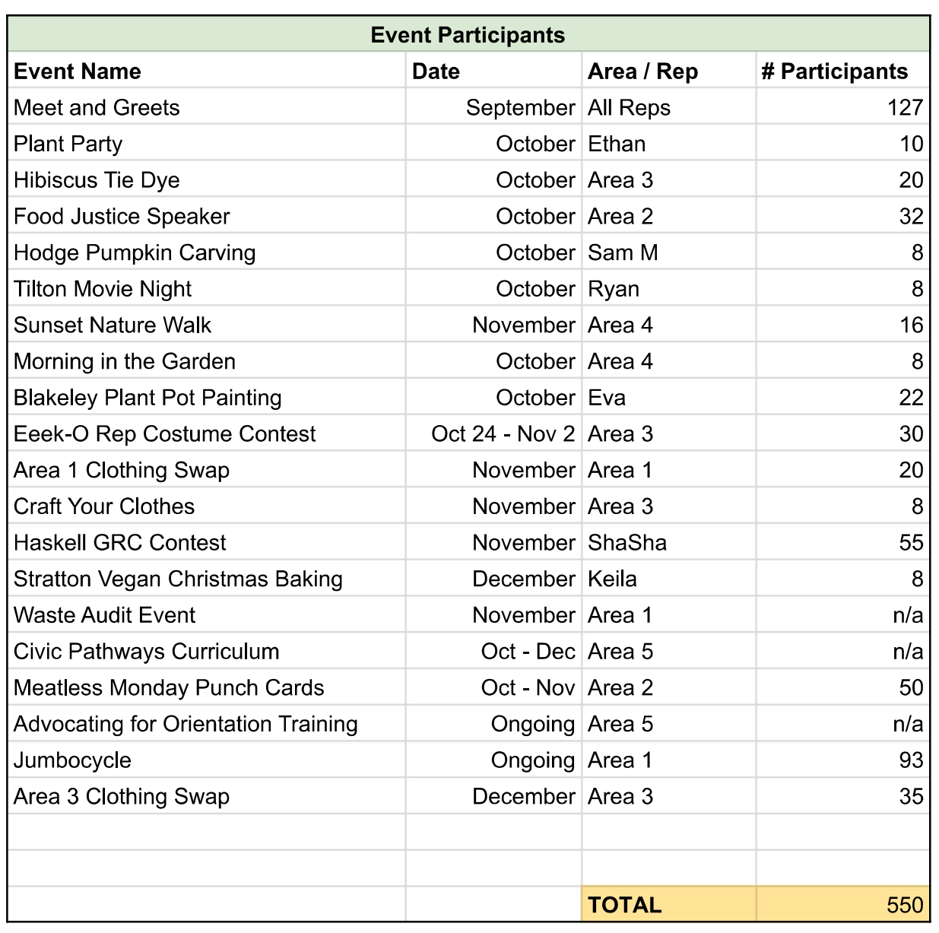

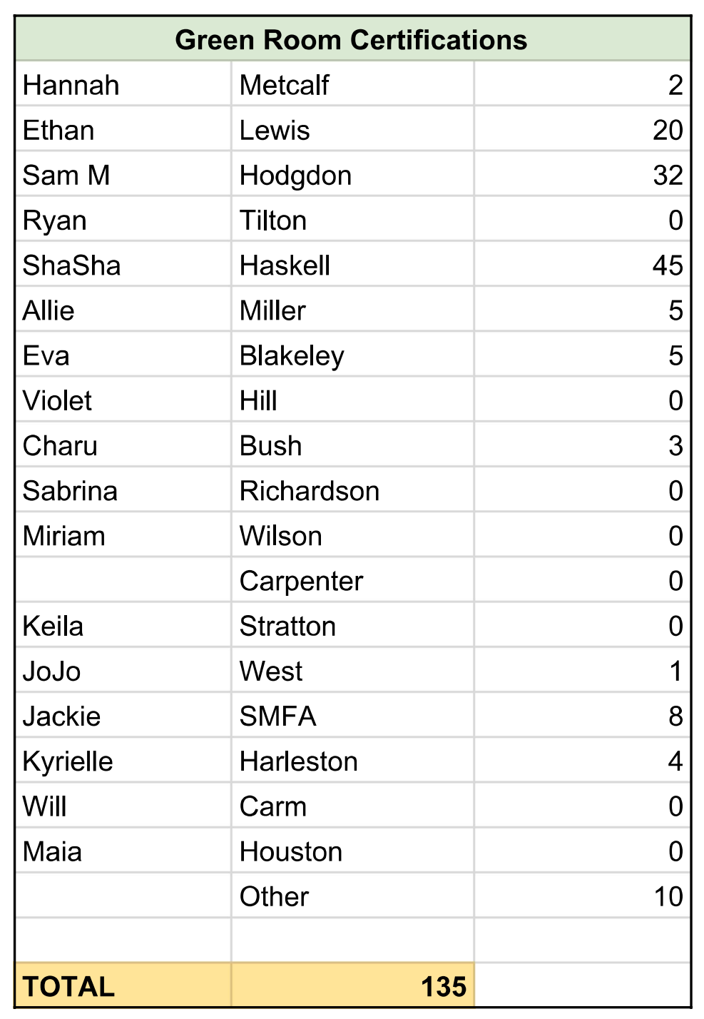
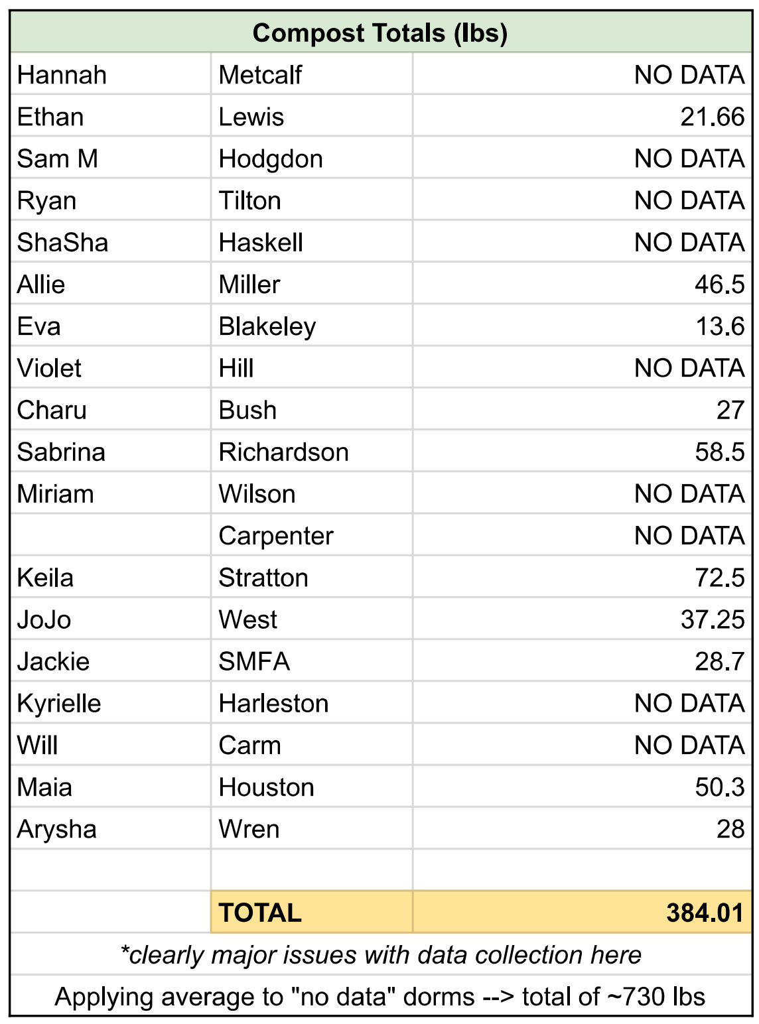
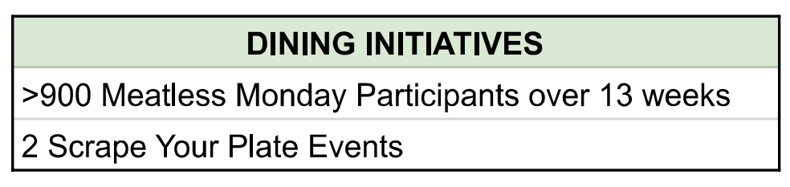
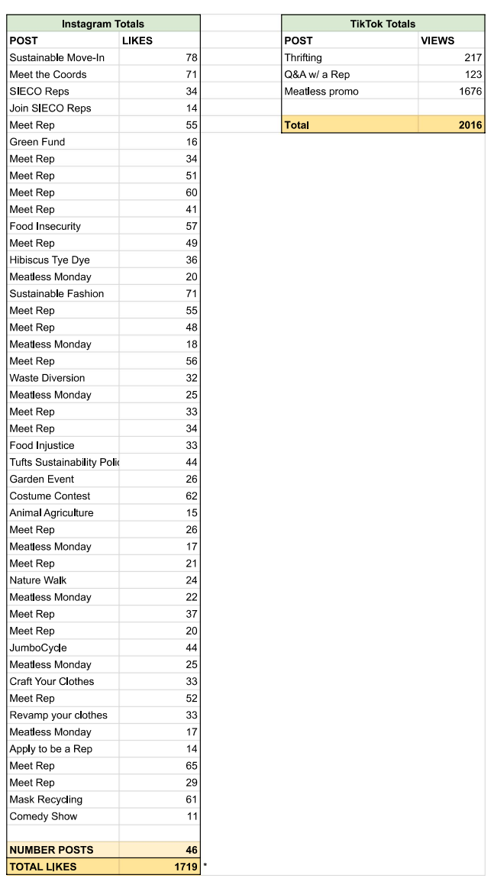

List of Eco Reps
* indicates Reps who are not returning
Bold indicates Area Leader
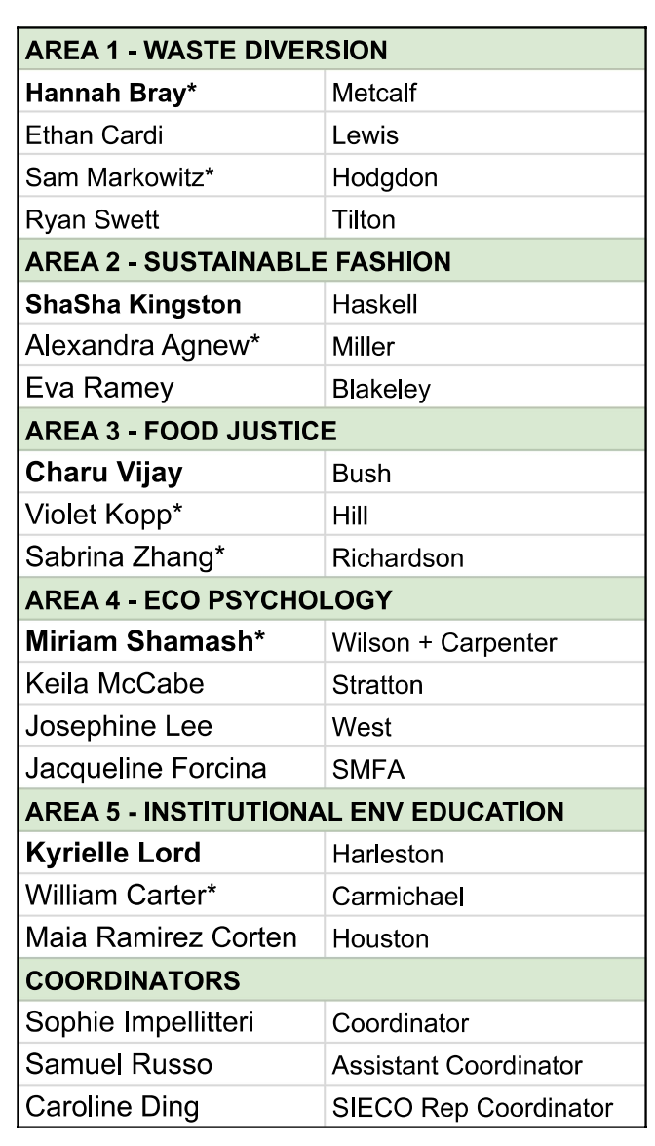

Reviewing Our Goals
These goals were set during training at the beginning of the semester and are not a great reflection of what the Areas actually worked on. This list below represents basically all of the ideas given by Eco Reps, and we did not go through the process of refining this list. Additionally, these goals were set after Area themes were chosen, so that further explains the misalignment in these and the work that was actually achieved.
For next semester, we plan to first set goals and then create Area themes and semester plans that are guided by those goals. We also plan to allot more time for goal setting, so that the list can be paired down to our priorities. Further, we will do a better job of revisiting our overarching goals throughout the semester to stay on track or revise.
For these reasons, many of the goals on the overarching list were not met, because again they were not a good reflection of the work actually being done by Areas. As an example of the Area specific goals, Area 2’s goals/plans that were set at the beginning of the semester are shown below - all of which were achieved. Every Area had at least 3 to 4 successful events or projects that worked towards their main goal.

Area 2 - Sustainable Clothing
- Educate students on the environmental impacts of fast fashion and ways they can reduce their impact
  - Hibiscus Tea Tie Dye Workshop
  - DIY Halloween Contest : who can make the best sustainably-sourced costume
  - Sewing/Embroidery Kit Grab n’ Go
  - Clothing Swap
  - Environmental justice educational fast fashion Instagram posts
  - Sustainable Halloween costume email memo

KEY:
Red - Not met
Yellow - Somewhat met
Green - Met

- Thinking beyond Tufts, getting involved with the community
  - Each group contact at least one env org beyond Tufts during the semester to be able to give our residents more resources
I put this as somewhat because the Food Justice area brought in a speaker from a local organization and the SIECO Reps participated in the Medford Energy fair. The other areas did not do this. Looking forward, we could do more with the ENVS department, such as excursions to volunteer with the Mystic Watershed organization.

- Improving Meatless Mondays (MM)
  - Work towards Dewick have some true Meatless Mondays
  - Talk to dining about having least popular meat dishes in Dewick on Mondays for next year
We maintained our good relationship with Dining and definitely brought both of these points to them, even if they have not implemented yet. Other improvements to Meatless Mondays include the punch cards and more stickers. Looking forward, we plan to rebrand MM this upcoming semester.

- Educate people about what they can do as individuals
  - Do pre and post survey this year to measure changes in knowledges
    - Try to get ORLL to send out
I think “educating people about what they can do as individuals” is a main part of the program, and I think we were fairly successful at that. We did not do a survey.

- Encourage students to get excited about Eco Reps (improve reputation)
  - Reach out to 4-5 social justice to groups to work with them during this semester
  - Post 1 TikTok a week and repost to our Instagram Reel
We did posted 3 TikToks total, not 1 a week. I don’t think any Areas worked with social justice groups. Based on end of year feedback, I don’t think we improved the program’s reputation.

- Successful events
  - Use some of your budget to have a raffle for exit survey for your event for improvement -- how inclusive/welcoming was the environment of the event?
  - Measuring what outreach got # of people there by asking at events
  - Having each Area do an Instagram takeover of Eco Rep account during semester
    - Also Tufts instagram in October for a day?
I think we can do much better with events. While the Reps worked hard to create interesting events, the attendance for many of these events falls short. Going into next semester we need to be more creative and strategic about actually reaching students in meaningful ways.
Each Area did create Instagram content that was pretty well received.

- Increasing awareness of composting
  - Emailing your residents every 1-2 weeks and include a reminder about composting + plastic film
  - Maybe a composting competition between dorms (not sure how exactly to do this) --- waste audit w/ prize
Reps did send out several emails about composting and plastic film (marked as yellow because unsure of exact frequency). No compost competition was held.

- Improving our waste systems
  - Put the Eco Map as a QR code on EVERY bulletin board
  - Waste station dorm audits -- ensure up to date signage on ALL waste stations in dorms
  - At least one specific email to residents about plastic film recycling from each Rep
  - Terracycle disposable masks in the dorms
  - Ask Michael Jordan about endorsing a reusable mask that we can promote
The QR code was on all the bulletin boards and a waste station dorm audit was completed. Plastic film was more greatly incorporated by having a box in every dorm with the compost bins. Terracycling masks is now available in several campus buildings, though not dorms. Last bullet point is moot based on the latest Tufts directive.

- Getting participation
  - 10 people each dorm to participate in Zero Waste Week
  - Partner with other groups for ZWW and add a social component (zero waste meal)
We did not do a campus wide ZWW this semester. We did reach ~500 people with events and a few thousand more on social media, but I think participation can be improved – several events had <10 people.

What went well, What we would change, and Recommendations looking forward
I think one of the things that went very well this semester was the overall culture of the program. Coming off of an almost entirely virtual program, it was great to see Reps actually bonding and enjoying working together. While there certainly was still frustration/dissatisfaction with the effectiveness of the program, I think there was a much more positive response in terms of how enjoyable the program was to be a part of. I think that this dynamic sets us up to be able to work together to make significant improvements to the program this upcoming semester.
I believe there are two broad problems that need to be addressed going forward, and I think they go together. First, there is a general unsureness about our main goals as a program and the effectiveness of those goals. Should we be focused on individual sustainable behaviours? Or is that an inaccurate/damaging approach to environmentalism? How do we balance/couple big and small perspectives? How do we evolve the program so that it is actually providing new information to students?
Second, a lot of our “traditional” events are falling short. Reps will spend weeks planning, gathering supplies, and promoting an event, only to have less than 10 people attend. If our goal is to reach lots of students, we need to rethink this. We need to create events that have wide appeal and draw. On the other hand, we could divert more energy into other methods of reaching students - tabling, working with dining, and social media are all high impact with arguably lower planning than our traditional events. Other ideas that have been mentioned are reaching students through the clubs/sports they are already part of. Additionally, Reps are welcome to pursue more “campaign” type activities, if they choose.
I think if we are able to address the first issue and define goals all of the Reps believe in and are passionate about, better events will follow. Many of the program’s shortcomings are the result of falling into the same patterns/habits of the program 10 years ago, which may or may not work today. We hope to use the start of the Spring 2022 semester to really evaluate these issues, create meaningful goals, and chart out impactful semester plans.

