Climate Change Is Real….

Climate change, or global warming, is caused mainly by burning fossil fuels (coal, oil, gasoline, and natural gas). This creates carbon dioxide (CO₂), a gas that stores heat. CO₂ and other gases that store heat are called “greenhouse gases.”

Natural greenhouse gases are necessary for life on earth. Without them, we could not live because the earth would be too cold. Too much of them, however, and global temperatures rise, the climate is destabilized, and our health and the health of the global ecosystem is in danger.

We have been putting more and more heat-trapping gases into the atmosphere, raising the average global temperature, and creating climate change.

The overwhelming majority of scientists agree that climate
change is real and poses a very serious global threat.

Climate change is happening today:

- Global temperatures are rising
- Sea levels are rising
- Severe weather events are increasing

Analysis of Antarctic ice sheets shows present-day atmospheric levels of heat-trapping CO₂ are 30% higher than at any other time in the last 420,000 years and are growing.
(Climate and atmospheric history of the past 420 000 years from Vostok ice cores in Antarctica, J.R. Petit, J. Jouzel, et al., Nature 399, pp 429-436, 1999.

We can expect to see:

- Further rise in severe storms, down-pours, and droughts;
- Great regional differences: Some areas will flood more, and other areas will suffer from increased droughts;
- Spread and increase of agricultural pests and tropical diseases such as hantavirus, malaria, and dengue fever;
- Severe damage to fragile ecosystems.
(IPCC Summary for Policy makers: Climate Change 2001: Impacts, Vulnerability and Adaptation. http://www.ipcc.ch/pub/wg2SPMfinal.pdf)


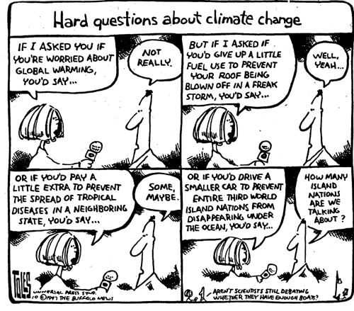

The United States has only 5% of the world's population yet contributes 25% of all greenhouse gases.

Each American is responsible for about 22 tons of CO₂ per year. If we want to stabilize the climate, each person on the planet should only produce about 2 tons of CO₂ per year.

Electricity production is the largest source of greenhouse gas emissions in the U.S. (33% in 2000, just ahead of transportation's 27%).

The 1990’s was the hottest decade on record, breaking the previous high mark… held by the 1980’s. And the trend continues: the 3 hottest years on record were 1998, 2002, 2003.

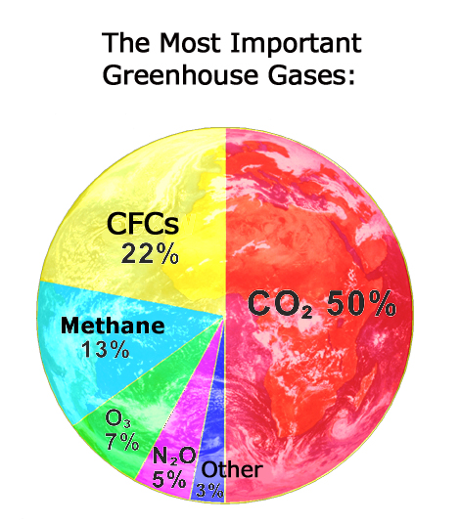
The Most Important Greenhouse Gases
and how much they contribute to climate change.
(Source: Dr. Martin Storksdieck)
Addressing Climate Change…

Many researchers believe that climate change is the most serious problem humanity has ever been faced with. Solutions to such a large problem have to come from many different levels:
- Global Political Action
- Local Action
- Personal Action

Global Political Action
The First World Climate Conference recognized climate change as a serious problem in 1979!!

Intergovernmental Panel on Climate Change (IPCC) is a body of more than 2,500 of the world's leading climate scientists, economists, and risk analysis experts from 80 countries. Established in 1988, the Panel was given a mandate to assess the state of existing knowledge about the climate system and climate change; the environmental, economic, and social impacts of climate change; and the possible response strategies.

IPCC released its First, Second and Third Assessment Reports in 1990, 1995, and 2001. Approved after a painstaking peer review process, the Report confirmed the scientific evidence for climate change. It had a powerful effect on both policy-makers and the general public and provided the basis for negotiations on the Climate Change Convention.

The 1992 UN Framework Convention on Climate Change was signed at Rio de Janeiro by 154 states, including the US. Twenty years after the 1972 Stockholm Declaration first laid the foundations of contemporary environmental policy, the Earth Summit became the largest-ever gathering of Heads of State.
(taken from: http://unfccc.int/resource/iuckit/fact17.html)

The United Nations Framework Convention on Climate sets out some guiding principles.
- The precautionary principle says that the lack of full scientific certainty should not be used as an excuse to postpone action when there is a threat of serious or irreversible damage.
- The principle of the "common but differentiated responsibilities" of states assigns the lead in combating climate change to developed countries.
- Other principles deal with the special needs of developing countries and the importance of promoting sustainable development.

Cumulative CO₂ Emissions from 1800-1988:
The Ecological Debt of the North
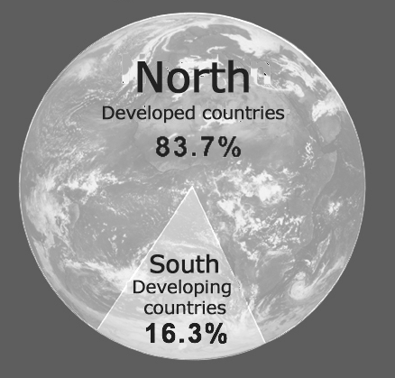
(Source: Dr. Martin Storksdieck)
Both developed and developing countries accept a number of general commitments. All parties will develop and submit "national communications" containing inventories of greenhouse-gas emissions by sources and greenhouse-gas removals by "sinks.” They will adopt national programs for mitigating climate change and develop strategies for adapting to its impacts. They will also promote technology transfer and the sustainable management, conservation, and enhancement of greenhouse gas sinks and "reservoirs" (such as forests and oceans). In addition, the parties will take climate change into account in their relevant social, economic, and environmental policies; cooperate in scientific, technical, and educational matters; and promote education, public awareness, and the exchange of information related to climate change.

Industrialized countries undertake several specific commitments. Most members of the Organization for Economic Cooperation and Development (OECD) plus the states of Central and Eastern Europe -known collectively as Annex I countries - are committed to adopting policies and measures aimed at returning their greenhouse-gas emissions to 1990 levels by the year 2000. (Only a handful of countries actually met this goal.)

The richest countries shall provide "new and additional financial resources" and facilitate technology transfer. These so-called Annex I countries (essentially the OECD) will fund the "agreed full cost" incurred by developing countries (Annex II ) for submitting their national communications. These funds must be "new and additional" rather than redirected from existing developmental aid funds.
(taken from: http://unfccc.int/resource/iuckit/fact18.html)
The Kyoto Protocol
(Taken from: http://unfccc.int/resource/iuckit/fact21.html)
The Kyoto Protocol to the United Nations Framework Convention on Climate Change strengthens the international response to climate change. Adopted by consensus at the third session of the Conference of the Parties (COP-3) in December 1997, it contains new emissions targets for Annex I (developed) countries for the post-2000 period.

The developed countries commit themselves to reducing their collective emissions of six key greenhouse gases by at least 5%. This group target will be achieved through cuts of 8% by Switzerland, most Central and East European states, and the European Union (the EU will meet its target by distributing different rates to its member states); 7% by the US; and 6% by Canada, Hungary, Japan, and Poland. Russia, New Zealand, and Ukraine are to stabilize their emissions, while Norway may increase emissions by up to 1%, Australia by up to 8%, and Iceland 10%. The six gases are to be combined in a "basket", with reductions in individual gases translated into "CO₂ equivalents" that are then added up to produce a single figure.

(Are you wondering how these numbers came about? Science? Magic? Well no, pure politics…this is why Australia's emissions, for example, can go up by 8% (because they said, if we cannot increase our emissions, we'll not support the treaty….) Well, this is how the real world works, unfortunately.)
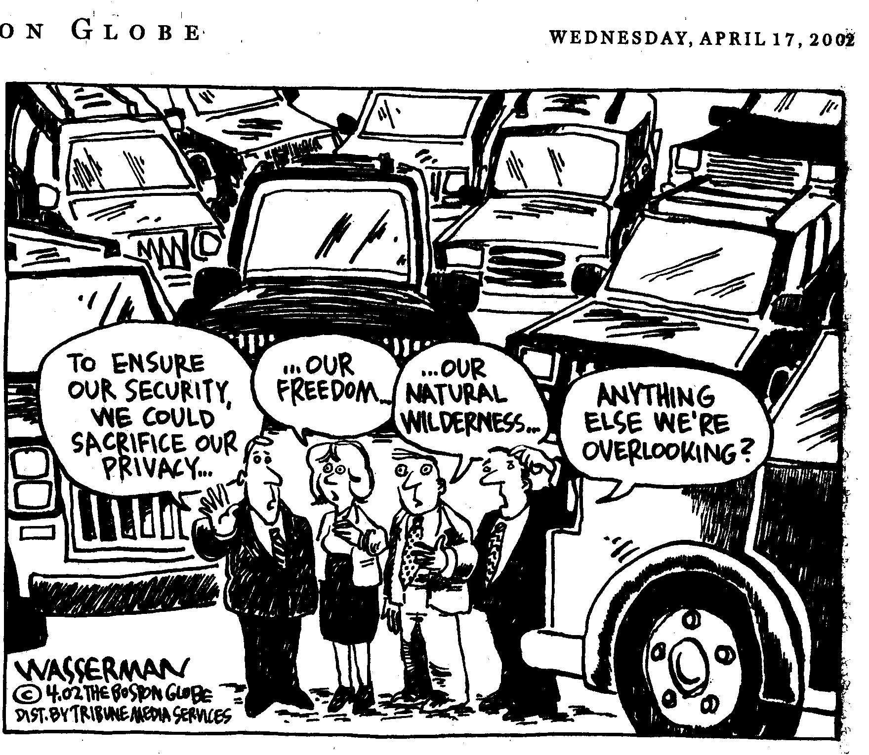
Each country's emissions target must be achieved by the period 2008-2012. It will be calculated as an average over the five years.

Since emissions levels would increase without a Protocol, actual emissions reductions will be much larger than 5%. If compared to the year 2000, the total cuts will equal about 10%. This is because many industrialized countries have not succeeded in meeting their earlier non-binding aim of returning emissions to 1990 levels by the year 2000, so that their emissions have in fact risen since 1990. Compared to the emissions levels that would be expected by 2010 without emissions-control measures, the Protocol target represents a 30% cut.

The small print:
The Kyoto agreement, will lower global emissions by 5% below 1990 levels (only if all countries actually stick to their commitment). If we want to stabilize atmospheric CO₂ emissions, we have to cut global emissions by 60-80%…..

Countries will have a certain degree of flexibility in how they make and measure their emissions reductions. In particular, an international "emissions trading" regime will be established allowing industrialized countries to buy and sell emissions credits amongst themselves. They will also be able to acquire "emission reduction units" by financing certain kinds of projects in other developed countries. In addition, a "clean development mechanism" will enable industrialized countries to finance emissions-reduction projects in developing countries and to receive credit for doing so. The operational guidelines for these various schemes must still be further elaborated.

(This is a very contentious issue: many countries fear that some of the rich countries (hear "US") will just buy their way out of their commitments without reducing their emissions in any real way.)

The Protocol was opened for signature for one year starting 16 March 1998. It will enter into force 90 days after it has been ratified by at least 55 Parties to the Convention, including developed countries representing at least 55% of the total 1990 carbon dioxide emissions from this group. In the meantime, governments will continue to carry out their commitments under the Climate Change Convention. They will also work on many practical issues relating to the Protocol and its future implementation at their regular COP and subsidiary body meetings.

(We all know that Bush is vehemently opposed to the Kyoto protocol. It looks like the world is going ahead without the US. The Kyoto Protocol entered into force on February 16th, 2005. To find out more about the treaty, go to http://unfccc.int)
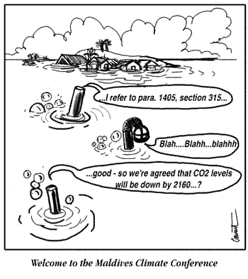

Local Action
Due of lack of action at the national level many local initiatives have been developed.

Tufts, Energy and Climate Change

Energy conservation is a big concern of Tufts University.
This box is way too small to list all of Tufts Energy projects which include lights, buildings, appliances, etc.

Tufts University committed to meet or beat the Kyoto agreement for university-related emissions. The Tufts Climate Initiative works on realizing this goal. You can learn more about us at: www.tufts.edu/tci

ICLEI:
Cities for Climate Protection (CCP) is a campaign of the International Council for Local Environmental Initiatives (ICLEI). CCP offers a framework for local governments to develop a strategic agenda to reduce global warming and air pollution emissions, with the benefit of improving community livability. Five hundred local governments are participating in the campaign, representing 8% of global greenhouse gas emissions, and the numbers are growing.

Learn more at: http://www.iclei.org/co2/index.htm

MCAN:
Massachusetts Climate Action Network (MCAN) is dedicated to halting the threat of global climate change. The MCAN Network is composed of numerous local and statewide environmental groups. The groups' efforts are principally devoted to conducting public education and influencing municipal governments in their home communities, to achieve local reductions in greenhouse gas emissions.
MCAN is also striving to change climate policy at the state level in Massachusetts, by influencing the state's climate action plan, legislation related to energy efficiency, renewable energy, and transportation; and regional planning efforts.

Learn more at: http://www.massclimateaction.org

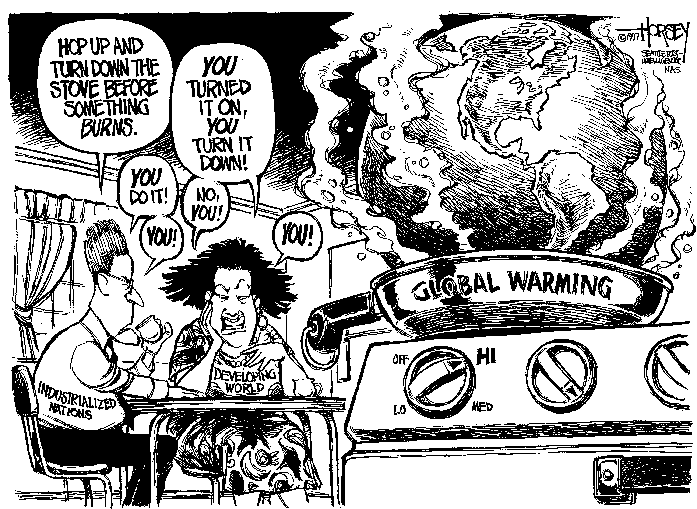

Personal Action: Be A Climate Hero!
As an individual, you can affect the emissions of about 4,800 pounds of carbon equivalent, or nearly 32% of the total emissions per person, by the choices you make in three areas of your life. These areas are the electricity we use in our homes, the waste we produce, and personal transportation. The other 68% of emissions are affected more by the types of industries in the U.S., the types of offices we use, how our food is grown, and other factors.
(taken from: http://yosemite.epa.gov/oar/globalwarming.nsf/content/emissionsindividual.html)

There are many actions you can take and encourage your fellow students to take to reduce CO₂ emissions:

Transportation  Drive less!  A third of U.S. greenhouse gas emissions come from transportation!  Fly less!  Flying somewhere produces as much CO₂ as if you would drive there in your car!  Buy a fuel efficient car!  You will cause much less pollution and save a lot of money!  Bicycle!  Biking creates zero emissions, and it’s fun!  At Home  Use your thermostat!  In the summer, set the thermostat for your air-conditioning higher: between 78-83 degrees. In the winter, set the thermostat for your heat lower: between 65-68 degrees during the day between 50-60 degrees at night.  Insulate your house!  New England homes are notorious for being poorly insulated: close storm windows, caulk-up cracks, and put plastic on your windows.  You’ll save money too! | Switch from oil to gas!  If you have an oil furnace, consider switching to gas. Oil produces much more CO₂ per unit of heat produced than natural gas. (By the way, electric heat is the most inefficient and most polluting of all three)  Turn off your lights!  Electricity comes mostly from coal power plants (and nuclear power plants) and is the largest source of CO₂ emissions in the U.S.  Buy Energy Star appliances!  These are especially energy efficient. Learn more about the Energy Star program at: www.energystar.gov  Recycle!  Recycling saves resources, reduces waste, and conserves energy!  More  Eat less meat!  Meat production is very energy intensive. If you eat less meat, you also prevent water pollution; it’s healthier too!  Buy less stuff!  You’ll save resources, energy, and money!  Check out: www.newdream.org/

Transportation And Climate Change
For the average American household, what action would reduce carbon emissions the most? A 10% reduction in:

a. vehicle miles traveled or
b. household electricity use?

On average, the reduction in vehicle miles traveled would have the largest impact on carbon emissions (about 20% greater). But both motor fuel and electricity use account for major shares of average household carbon emissions, so both offer attractive targets for emissions reductions. Results for your household may differ from the average case where over 50% of electricity is generated from coal.
What’s your transportation budget? Think about the ways you travel each day and consider where the emissions come from. The following pages give you some information and pointers on where to go for more information about how your transportation choices affect the global climate.
The transportation sector is a climate-changing beast: it accounts for fully 32 percent of U.S. carbon-dioxide emissions.

- Americans drive 1.5 trillion miles per year in automobiles alone, and drive an additional 600 billion miles in personal trucks and SUVs.
- Automobiles and light trucks combined consume 115 billion gallons of gasoline and diesel fuel per year.
- Each year, 65% of the fossil fuel consumed in the United States is used for transportation.

(Rocky Mountain Institute, www.rmi.org; US Dept. of Energy: www.eren.doe.gov/EE/trans_basics.html)

What Other Pollution Come From Transportation?
(Nebel, B. J. (1990). Environmental science: The way the world works (3rd ed.). Englewood Cliffs, NJ: Prentice.)
- Photochemical Smog. Photochemical smog is the brownish haze that develops when certain pollutants react with sunlight. This smog usually forms in cities with high automobile traffic.
- Hydrocarbons. Hydrocarbons result mostly from the incomplete burning of gasoline and as fumes that escape when filling the tank. They are prime contributors to photochemical smog and are toxic and carcinogenic.
- Carbon Monoxide (CO). CO, also a combustion product, is a poisonous gas that impairs the flow of oxygen to the brain and other parts of the body.
- Fine airborne particulate matter (PM) causes lung trouble: shortness of breath, worsening of respiratory diseases and heart conditions, lung damage, and cancer.
- Nitrous oxides (NOx). When NOx is present with hydrocarbons, damaging compounds like ozone and acid rain develop. NOx aggravate respiratory problems, both directly and indirectly, by forming PM and smog; NOx also causes acid rain and damages aquatic environments.
- Ozone. In the upper atmosphere, ozone screens out ultraviolet rays. However, ground level ozone, created from byproducts of incomplete automobile exhaust, can be highly toxic to both plants and animals. Ground level ozone is also a potent greenhouse gas.
- SOx irritates the lungs, and it contributes to forming PM and acid rain.

How Can I Be a “Greener” Driver?
(If not referenced otherwise, all information about driving has been taken from: www.fueleconomy.gov)

Buy a car that gets good gas mileage!
E.g. A Ford Excursion gets 11 mpg, a Honda Civic gets 30mpg, a Toyota Prius and a Honda Civic Hybrid get 50 mpg. Did you know that Tufts Building and Grounds is driving a Prius? Look out for it!

Rate your car for “Green-ness” and find the greenest models? www.GreenerCars.com
Calculate your vehicle's emissions at www.environmentaldefense.org/tailpipe
Another very helpful site with lots of in formation: www.fueleconomy.gov/


Driving Habits

Drive Sensibly
Aggressive driving (speeding, rapid acceleration and braking) wastes gas. It can lower your gas mileage by 33 percent at highway speeds and by 5 percent around town. Sensible driving is also safer for you and others, so you may save more than gas money.

Fuel Economy Benefit: 5-33%
Equivalent Gasoline Savings: $0.07-$0.49/gallon

Observe the Speed Limit
Gas mileage decreases rapidly at speeds above 60 mph. Each 5 mph you drive over 60 mph is like paying an additional $0.10 per gallon for gas. Observing the speed limit is also safer.

Fuel Economy Benefit: 7-23%
Equivalent Gasoline Savings: $0.10-$0.34/gallon

Avoid Idling
Idling gets 0 miles per gallon. Cars with larger engines typically waste more gas at idle than do cars with smaller engines.

Use Cruise Control
Using cruise control on the highway helps you maintain a constant speed and, in most cases, will save gas.

Use Overdrive Gears
When you use overdrive gearing, your car's engine speed goes down. This saves gas and reduces engine wear.

Don't use the car to store items
Avoid carrying unneeded items, especially heavy ones. An extra 100 lbs in the trunk reduces a typical car's fuel economy by 1-2 percent.
On the other hand, a roof rack or carrier provides additional cargo space and may allow you to meet your needs with a smaller car. However, a loaded roof rack can decrease your fuel economy by 5 percent. Reduce aerodynamic drag and improve your fuel economy by placing items inside the trunk whenever possible.

Car Maintenance

Keep Your Engine Properly Tuned
Fixing a car that is noticeably out of tune or has failed an emissions test can improve its gas mileage by an average of 4.1 percent, though results vary based on the kind of repair and how well it is done. If your car has a faulty oxygen sensor, your gas mileage may improve as much as 40 percent.

Fuel Economy Benefit: 4-40%
Equivalent Gasoline Savings: $0.06-$0.60/gallon

Check & Replace Air Filters Regularly
Replacing a clogged air filter can improve your car's gas mileage by as much as 10 percent. Your car's air filter keeps impurities from damaging the inside of your engine. Not only will replacing a dirty air filter save gas, it will protect your engine.

Fuel Economy Benefit: up to 10%
Equivalent Gasoline Savings: up to $0.15/gallon

Keep Tires Properly Inflated
You can improve your gas mileage by around 3.3 percent by keeping your tires inflated to the proper pressure. Under-inflated tires can lower gas mileage by 0.4 percent for every 1 psi drop in pressure of all four tires. Properly inflated tires are safer and last longer.

Fuel Economy Benefit: up to 3%
Equivalent Gasoline Savings: up to $0.05/gallon

Planning and Combining Trips
Combining errands into one trip saves you time and money. Several short trips taken from a cold start can use twice as much fuel as a longer multipurpose trip covering the same distance when the engine is warm. Trip planning ensures that traveling is done when the engine is warmed-up and efficient.

With a little planning, you can avoid retracing your route and reduce the distance you travel as well. You'll not only save fuel, but also reduce wear and tear on your car.

Commuting
If you can stagger your work hours to avoid peak rush hours, you'll spend less time sitting in traffic and consume less fuel.
If you own more than one vehicle, drive the one that gets the best gas mileage whenever possible.
Consider telecommuting (working from home) if your employer permits it.
If possible, take advantage of carpools and ride-share programs. You can cut your weekly fuel costs in half and save wear on your car if you take turns driving with other commuters. Many urban areas allow vehicles with multiple passengers to use special High Occupancy Vehicle (HOV) lanes.
A gallon of gasoline weighs just over 6 pounds. When burned, the carbon in it combines with oxygen from the air to produce about 19 pounds of CO2.

But counting the energy that went into making and distributing the fuel, the total global warming impact equals 28 pounds of CO2 emissions per gallon.
(Source: http://greenercars.com/whybuy.html)

Of course, the best thing is to avoid the car altogether:
to walk, to bike or to use public transportation!
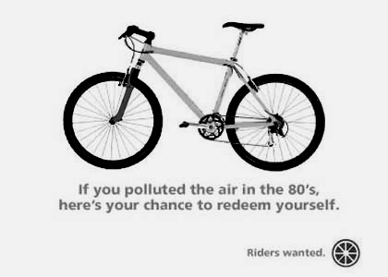
(Source: adbusters.org)

A bicycle gets 2000 mpg!
One gallon of gasoline is equivalent to the food energy you would need to bike 2000 miles!!!

FLY THE FRIENDLY SKIES?
Due to the airline and aircraft manufacturers' great technical and operational progress over the past three decades, airline fuel economy per passenger mile has improved by 61 percent. However, the growth in air travel is outpacing airline fuel efficiency gains—Americans now fly 764 million trips per year (2.85 airplane trips per person, averaging 814 miles per trip)—and energy used by commercial aircraft has nearly doubled in the same period. This jet fuel consumption translates to 13 percent of total transportation sector emissions of carbon dioxide in the US.
Because airplanes emit nitrous oxide (NO_{x}) and other pollutants at high altitudes, the Intergovernmental Panel on Climate Change (IPCC) estimates that such pollutants increase the climate impact of flying by a factor of at least 2.5 compared to the combustion of jet fuel alone.
Air travel is the most energy intensive intercity mode of transportation, producing about one fifth more (depending on source) CO₂ per mile per passenger than traveling by car.
Right now, the world's airplanes pump out more than 700 million tons of carbon dioxide annually, adding almost as much to climate change per year as the whole of Africa. (Transport energy data book, WRI) Globally, air traffic has risen at more than twice the rate of economic growth since 1960. Meanwhile, the number of people flying worldwide is expected to double in the next 15 years. (Aviation and Global Climate Change report)
(taken from Rocky Mountain Institute: http://www.rmi.org/sitepages/pid600.php)

In 1999 the world’s top climate scientists, the Intergovernmental Panel on Climate
Change(IPCC), published a detailed study of the impact of aircraft pollution on our
atmosphere - Aviation and the Global Atmosphere (see website http://www.ipcc.ch/index.htm).The report’s findings support the following:

- Aircraft cause about 3.5% of global warming from all human activities.
- Aircraft greenhouse emissions will continue to rise and could contribute up to 15% of global warming from all human activities within 50 years.
- Nitrogen oxides(NOx) and water vapor have a more significant effect on the climate when emitted at altitude than at ground level. Hence any strategy to reduce aircraft emissions will need to consider other greenhouse gases and not just CO₂ alone.
- Aircraft vapour trails or contrails, often visible from the ground, can lead to the formation of cirrus clouds. Both contrails and cirrus clouds warm the earth’s surface magnifying the global warming effect of aviation.
- The impacts on the global atmosphere from air travel will be concentrated over Europe and the USA where 70-80% of all flights occur. Hence the regional climatic impacts of aircraft emissions over these areas are likely to be greater than predicted by the IPCC report(which used global averages).
- Improvements in aircraft and engine technology and in air traffic management will not offset the projected growth in aircraft emissions. That is, we need to slow the growth in air travel if we want to reduce the growth in aircraft greenhouse gas emissions.
(taken from: http://www.foe.co.uk/resource/reports/aviation_climate_change.pdf)
Calculate the emissions of your last trip: www.chooseclimate.org/flying/mapcalc.html

Take vacations nearer to home, or get there by train, bus, boat, or even car!

Lights, Electricity, And Climate Change

Electricity
Lighting, most of which is from inefficient incandescent lights, uses about 25% of all electricity in the United States. Electricity is produced mostly by burning fossil fuels. In Massachusetts, the fuel mix for electricity production is:
26% natural gas
11% nuclear
29% oil

28% coal
1% hydro
0% solar and wind
(http://www.eia.doe.gov/cneaf/electricity/st_profiles/massachusetts/fig2.html)

Shut Off Your Lights!
Turn off your lights when you don’t need them. It sounds so simple: at no cost and with very little effort you save money and energy, and prevent your bulbs from burning out fast and the climate from heating up. Now you just need to remember...

Compact Fluorescent Bulbs
Yes, Compact Fluorescent Bulbs are much more expensive to buy than ordinary bulbs. But even though they cost between $8-12 each, they will save you much more money in the end.

Check for rebates! Sometimes you can buy CFBs for as little as $1 a piece!
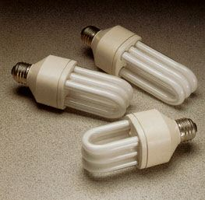
- A Compact Fluorescent Bulb lasts ten times longer than an incandescent bulb.
- A single Compact Fluorescent Bulb saves $25-50 in bulb and electricity costs over its lifetime!
- Over its lifetime, one single Compact Fluorescent Bulb prevents 1,000-2,000 pounds of carbon dioxide from heating the atmosphere.
- It also prevents the emission of 8-16 pounds of sulfur dioxide, which causes acid rain.
- The same Compact Fluorescent Bulb will also save the cost of buying and installing a dozen ordinary bulbs.

Tufts Light Bulb Exchange Program
Tufts students, staff, and faculty can bring their incandescent bulbs to the Tufts Climate Initiative office in Miller Hall (Medford Campus) and get one free Compact Fluorescent Bulb.
If you have questions call TCI at: 617-627-5517

Halogen Torchieres
One single halogen torchiere can cost you between $50 and $160 in electricity costs each year.

A comparable standing lamp with Compact Fluorescent Bulbs will cost you only $4 - $14 in electricity costs a year. Halogen torchieres pose a fire hazard. For that reason:

Halogen Torchieres are prohibited at Tufts!

Climate Change Is Real ... Turn Off Your Computer!

- Turn off your computer at night and when you are not using it for several hours.
- Enable the Power Management feature for your monitor (see below).
- Turn off your monitor when you aren't using your computer for 15 min. or longer.
- If you buy a new computer, consider a laptop. Laptops use only 1/4 the energy.
- If you buy a new monitor, consider a flat screen. They use only 1/3 the energy.

Computer Myths And Facts

Myth #1: Turning off my computer is bad for my computer - Wrong!

Fact
The Lawrence Berkeley National Laboratory states that modern hard disks are not affected by frequent shut-downs and that equipment may actually last longer because mechanical wear and heat stress are reduced.

Action
Turn off your computer during the night!

Savings
If all students at Tufts University turned off their computers at night for 6 hours, it would prevent 572 tons of CO₂ from heating the atmosphere each year and save over $87,000 in electricity costs!

Security Benefit
When you turn your computer off, you decrease the risk of someone accessing your files or e-mail.

Myth #2: Computers don't really need a lot of power if they are on but not used - Wrong!


Fact
During heavy usage (e.g., when you open a new application) your computer draws only slightly more power. The average computer uses about 120 Watts (75 Watts for the screen and 45 Watts for the CPU) whether you're using it or not.

Action
Turn off your computer if you are not using it for 1 hour or more!

Savings
If each household in the metro Boston area turned off their computer just one additional hour per day, we could save $3.2 million in electricity costs and prevent 19,000 tons of CO₂ from heating the atmosphere. If businesses and universities were included, the savings could be much greater.
One computer left on 24 hours a day will cost you $115 - 160 in electricity costs a year and dump 1,500 pounds of CO2 into the atmosphere.

A tree absorbs between 3-15 lbs of CO2 each year. That means that 100-500 trees would be needed to offset the yearly emissions of one computer left on all the time!

Myth #3: Screen savers save -Wrong!

Fact
Despite the name, screen savers don't save anything, especially not power!

Action
Turn off your monitor if you are not using your computer for more than 15 minutes!

Savings
If Tufts students and staff turned off their computer monitors 1-5 hours a day, it would prevent 118 - 590 tons of CO₂ from heating the atmosphere each year and save Tufts $18,000 - $90,000 in electricity costs!


Enable The Power Management Feature On Your Computer

The instructions differ slightly from system to system. For more information go to:
www.tufts.edu/tci/powermanagement.html

On PCs (running Windows)
1. Right-click on your desktop. A dialog box appears.
2. Select Properties.
3. Select Screen Saver tab.
4. Select Energy Saving Features.
5. Select Settings.
6. Select the number of minutes after which you want your screen (and your CPU) to power down. We recommend something between 5-15 minutes. Not all computers let you install Power Management features (e.g. Windows NT). If you have trouble on older machines, disable this feature.

On Macs
1. Go to the Apple Icon.
2. Select Control Panels.
3. Select Energy Saver.
4. Select Show Details.
5. Check Separate Timing for Display Sleep.
6. Select the number of minutes after which you want your screen (and your CPU) to power down. We recommend something between 5-15 minutes.

What, you haven’t had enough??

Ok, here is:

MORE ON GLOBAL WARMING
(written for MCAN conference 2001 by Dr. Daniel Kirk-Davidoff,
Assistant Professor, Dept. of Meteorology, University of Maryland)
What’s the difference between global warming and the greenhouse effect?
The "greenhouse effect" refers to the natural phenomenon that keeps the earth at just the right temperature for life to flourish. The sun's enormous energy warms the earth's surface and its atmosphere. This energy radiates back toward space as heat, but a portion is retained by the delicate balance of heat-trapping gases in the atmosphere - among them carbon dioxide and methane - which create an insulating layer. Without the temperature control of the greenhouse effect, the earth could not sustain life. As some people have put it: too much greenhouse gas, and Earth would be as hot as Venus; too little and we’d be cold as Mars.

"Global warming" refers to the rise in the earth's overall temperature resulting from an increase in heat-trapping gases in the atmosphere.

What is causing global warming?
Scientists have concluded that human activities are contributing to global warming by adding large amounts of heat-trapping gases to the atmosphere. Our use of fossil fuels - coal, oil, and wood - is the main source of these gases. Every time we drive a car, use electricity from coal-fired power plants, or heat our homes with oil, we release carbon that has been stored in the earth for millennia. The carbon then mixes with oxygen to form carbon dioxide (CO₂), a greenhouse gas. For hundreds of thousands of years, the CO₂ concentration in the atmosphere never rose much above 280 parts per million. Since the industrial revolution, though, atmospheric concentrations of carbon dioxide have increased by 30 percent to 360ppm.

Over the same period, atmospheric methane has risen by 145 percent, mostly from agricultural activities like growing rice and raising cattle. Methane is a potent greenhouse gas - twenty times
as efficient at trapping heat as CO₂. But CO₂ remains stable in the atmosphere far longer (100 years) than methane and so has a longer-term impact on the climate.

As the concentration of these gases grows, more heat is trapped in the earth’s atmosphere and less radiates back into space. This increase in trapped heat alters atmospheric processes and their interaction with the oceans and the land. And the climate -- the product of that interaction -- changes as well, causing altered weather patterns that bring unexpected rain or dry spells and sudden, severe storms.

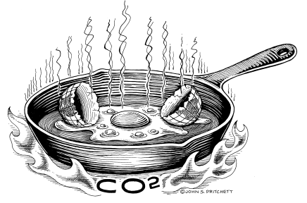

Is global warming already evident, or is it something that will happen in the future?
Evidence over the past decade suggests that warming is already underway. Surface temperatures in the Pacific Ocean have risen 3º F; glaciers are retreating at an unprecedented rate; the polar ice shelves are thinning markedly. In the northern hemisphere, eleven of the hottest years ever recorded occurred in the past two decades. The three hottest ever were 1998, 2002, and 2003. Because of this, spring arrives two weeks earlier in the northern hemisphere today than 20 years ago. Average global temperature rose by 1º F during the 20th century, and most of this increase took place during just the past 25 years.

How do we know that recent warming is caused by human activity, rather than part of the natural variability of the climate?
Climate is variable, so naturally we can never be 100% certain. But, to quote the American Geophysical Union, an international scientific society with more than 35,000 members, “the present level of scientific uncertainty does not justify inaction in the mitigation of human-induced climate change.” So compelling is the scientific evidence that the Intergovernmental Panel on Climate Change, a panel of the world's leading climate scientists, concluded in 1995 that “the balance of evidence suggests that there is a discernible human influence on global climate.” Since then, the evidence has gotten much stronger. (American Geophysical Union, January 28, 1999
AGU RELEASE NO. 99-03)

Not only has the rise in average global temperatures exceeded what might occur simply by chance, but also the pattern of change is consistent with the hypothesis of human-induced warming. Warming due to a buildup of greenhouse gases, for example, is predicted to cause sharper spikes in nighttime than in daytime temperatures. This pattern - which would not occur if warming were caused by increased solar energy - is, in fact, what scientists observe. Human-induced warming is also expected to cause an increase in extreme weather events - floods, droughts, and heat waves - which have also increased dramatically in recent years.

But don’t scientist disagree on this?
There is no debate among scientists actually working on this issue that human activities are raising the temperature of the planet. The few dissenting voices are, with very few exceptions, in the pay of the fossil fuel lobby - coal and oil producers, automakers, and utilities. For more information on this, see The Heat is On by Ross Gelbspan.

If the planet is warming, why is it so cold sometimes?
We should not be lulled from concern by the occasional cold snap. Even as the planet’s overall climate changes, weather - the state of the atmosphere at a given time and place - will continue to vary from day to day, season to season and from region to region.

What is the best source of scientific information on global warming?
In 1988, the United Nations Environment Programme and the World Meteorological Organization set up the Intergovernmental Panel on Climate Change to examine the most current scientific information on global warming and climate change. More than 2,500 of the world's leading climate scientists, economists, and risk analysis experts from 80 countries contributed to the panel's report, Climate Change 2001: The IPCC Third Assessment Report. Since then, the IPCC has published a number of other studies and technical documents. The US Environmental Protection Agency is also a rich source of information. www.ipcc.ch www.epa.ch www.unfccc.de

How much warmer is the earth likely to become?
The 2001 report from the IPCC projects that the earth's average surface temperature will increase between 3° and 10°F in the next 100 years. This is in addition to the increase of 0.5° to 1.1°F that has already occurred since 1860. Scientists predict that even if we stopped emitting heat-trapping gases now, the climate wouldn't stabilize for many decades because of the gases we've already sent into the atmosphere.
(IPCC Summary for Policy makers: Climate Change 2001: The Scientific Basis. http://www.ipcc.ch/pub/spm22-01.pdf)
These figures, moreover, are planetary averages. Larger increases will occur in some regions, smaller increases in others. The US National Climate Assessment Program estimates that warming will be above average over the continental US (one model predicted a 10ºF temperature rise by 2100).

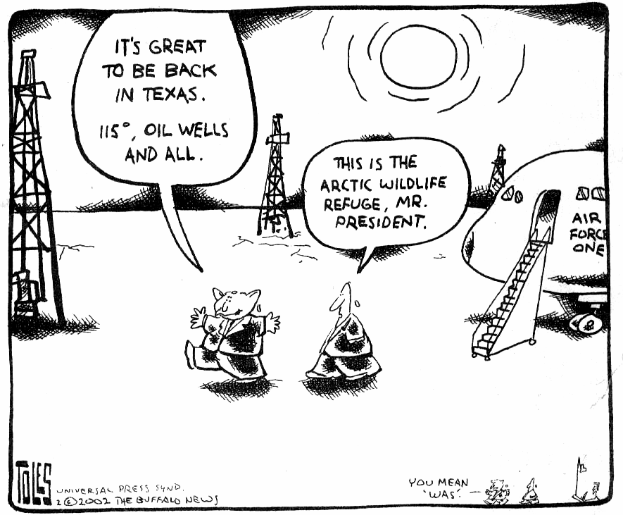
Would a temperature increase of a couple degrees really change global climate?
Remember that even a 1º to 2ºF increase in body temperature can send a person to bed. Similarly, a modest rise in the earth’s temperature of 2° to 3°F could have dramatic effects. Over the past 10,000 years, the earth's average temperature hasn't varied by more than 1.8°F. During the last Ice Age, in which the Northeast was covered by a kilometer of ice, average temperatures were only 5° to 9°F cooler than those today.

Nor will an increase of a few degrees make for pleasantly warmer temperatures around the globe. Some regions may be affected more profoundly than others. Some may receive less rainfall, with severe impacts on agriculture and forests. Others may lose coastal wetlands through rises in sea level. Agriculture in low-lying areas, such as along the Mississippi River, could be severely affected by floods. Scientists predict that continued global warming is likely to result in:

- a rise in sea level between 6.0 and 37 in. (15 - 95 cm) and consequent coastal flooding
- severe stress on forests, wetlands, and other ecosystems
- damage to human health as mosquitoes and other insects spread diseases over larger geographical regions (think West Nile virus!)
- disruption of agriculture through changes in temperature and water resources

Are there any benefits to global warming?
Spokespeople for the fossil-fuel industry like to point out that carbon dioxide, far from being a pollutant, is “plant food.” Some argue that increased carbon concentrations and warmer temperatures will enhance plant and tree growth, lengthen growing seasons and generally lead to more comfortable weather in temperate zones. But any beneficial impacts could easily be overwhelmed by such negative consequences as drought and insect infestation. It is, in fact, impossible to predict the myriad ways climate change will impact the planet and neither climate scientists nor coal industry spokesmen know what the net effect on human life will be. Ecologist Herman Daly has proposed that environmental policy be guided by the rule that we do not destroy what we cannot now replace. Most would agree that the planet’s climate is irreplaceable.

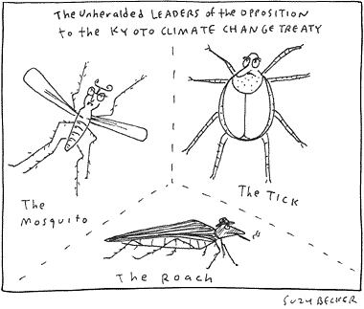

Is global warming connected to the hole in the ozone layer?

Global warming and ozone depletion are two separate threats, although some gases contribute to both.
Chlorofluorocarbons (CFCs "Freon"), for example, are the principal cause of ozone depletion, and they are also potent heat-trapping gases. In fact, the chemicals used to replace CFCs, such as hydrochlorofluorocarbons (HCFCs) and hydrofluorocarbons (HFCs, now widely used in automobile and domestic air conditioning systems), may be an added source of global warming, since they are potent heat-trapping gases and their concentrations in the atmosphere are rising quickly. But these gases are responsible for less than 10 percent of total atmospheric warming. Carbon dioxide, on the other hand, accounts for two-thirds of excess greenhouse gases. While reducing atmospheric concentrations of CFCs is crucial to preventing continued destruction of the ozone layer, it won’t in itself solve the problem of global warming.

Are there things we do to deal with warming that worsen the problem?
Yes! When temperatures rise, households and businesses turn up the air-conditioning, consuming more electricity that is generated largely by coal-fired power plants in the US.

But won’t cutting greenhouse gas emissions destroy the US economy?
Sharply reducing our use of oil and coal will certainly harm the oil and coal industries and any plan to address global warming should include retraining and assistance for displaced workers in those industries. But the overall economy would most likely benefit from efforts to stabilize the climate. As electric utilities develop renewables, as businesses retro-fit factories to operate more efficiently, as consumers replace appliances, as firms insulate and upgrade buildings -- all of these will generate new jobs and incomes in a wide variety of trades. Studies by both the Tellus Institute and the EPA estimate that CO₂ reduction policies will result in a modest but significant increase in jobs over the next decade. Economist Janet Yellen, while Chair of Council of Economic Advisors testified to Congress that she does not “anticipate any significant aggregate employment effect” from reducing greenhouse gas emissions.

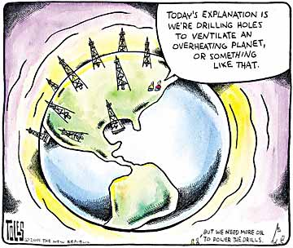

But won’t cutting emissions reduce the US standard of living?
Americans today use two to three times as much energy per capita as do residents of Japan and Europe, whose living standards are quite similar. Simply by applying known efficiencies already in use elsewhere, we could cut our fossil fuel consumption by 20% or more. Shifting from fossil fuel to renewables, without cutting back on overall energy use, can likely make further reductions. Reducing emissions by more than this, though, will eventually necessitate changes in lifestyle and energy use by households (more walking, biking, public transportation) and by businesses (fewer neon billboards). Whether such efficiencies imply a reduction or an improvement in living standards is hard to say. Environmental groups believe that, eventually, humanity must learn to live on renewable energies like solar, wind, and biomass. Switching to renewables will also reduce other sorts of pollution caused by fossil fuels - like smog and acid rain.

