Community Based Social Marketing Worksheet

Name:
Click here to enter text.

Step 1: Selecting Behaviors
- What is the problem you are trying to solve (e.g. reducing paper waste in the office)?
Click here to enter text.

- What is the specific behavior you are trying to change (e.g. get people to use own mug instead of paper cup)?
Click here to enter text.

- Whose behavior needs to change (e.g. professors who print-out course material)?
Click here to enter text.

- What stage of change are they in?
Click here to enter text.

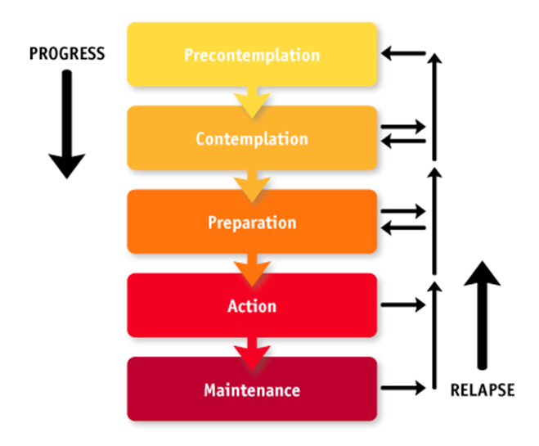
Figure 1. Stages of Change

Step 2: Identify Barriers and Benefits
- Are there any of the following barriers to behavior change?
  - Infrastructural (e.g. no recycling bins, printer doesn’t print double sided)
Click here to enter text.

  - Organizational (e.g. you don’t know who the decision maker is to get something changed, financial systems don’t allow the change)
Click here to enter text.

  - Social dynamics (e.g. your ‘audience’ doesn’t want to be seen as different, they’re resistant to change, your status within the office inhibits your ability to introduce new behavior)
Click here to enter text.

  - Individual (attitude, habits, lack of knowledge)
Click here to enter text.

- What benefits will the person see from performing the new behavior? (e.g. new behavior is easier, more satisfying, saves money, provides recognition)
Click here to enter text.

Step 3: Develop Strategies
- What communication strategies will you use to communicate with your audience? (think about the Alpha vs. Omega strategies and framing)
Click here to enter text.

- What tools will you use? (e.g. commitments, prompts, norms, incentives, enhanced conveniences, adding infrastructure, etc.)
Click here to enter text.

Steps 4 & 5: Implementation
- Do you need to pilot test your campaign?
Click here to enter text.

- When will you start?
Click here to enter text.

- Who do you need to help you?
Click here to enter text.

- Do you need any resources?
Click here to enter text.

Step 6: Evaluation
- How will you measure success?
Click here to enter text.

