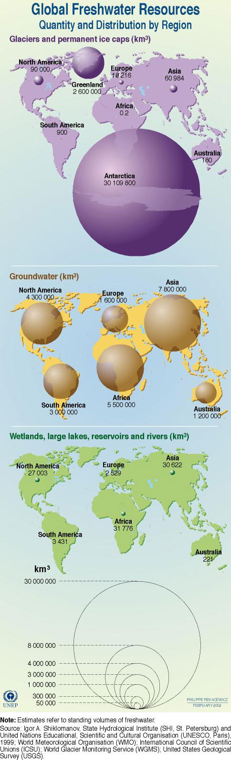
Fresh Water!

“Water, water, everywhere.” That’s what we usually think of when it comes to water—especially here at Tufts when you see it coming out of faucets, drinking fountains, and showerheads without ever having to pay for it. When you think about conserving it or making more efficient uses of it, you might wonder “Why should I? I’ve got as much of it as I need and if I use more, who cares? Besides doesn’t the university just pay for it?”

Yet, water shortages, lack of safe drinking water, water contamination, and groundwater depletion are some of the most serious environmental issues we are facing as a global community. The world’s water supply is shrinking at an alarming rate, and what used to be—or seemed to be—free will no longer be.

Global Water Facts

How Much Of Earth's Water Is Usable By Humans?

- Less than 1% of all water is fresh water,
- 99% is salt water.
- Of that 1%, most of it is in ice caps or in deep aquifers, which means that it is not really accessible for consumption.
(Source: ga.water.usgs.gov/edu/earthwherewater.html)

(You might think that here in New England we are not faced with a water problem since we get so much rain and snow. But that is actually not true. Many of the rivers dry out in the summer, because too much water is drawn from them. Also, with climate change, we can expect to get more droughts here in the Northeast. More about US and local water issues further on)

FRESHWATER IS A SCARCE RESOURCE
(Taken from: http://www.unep.org/wed/2003/keyfacts.htm)

Water makes up 60 to 70 per cent (by weight) of all living organisms and is essential for photosynthesis.

Water covers 75 per cent of the Earth’s surface — 97.5 per cent of that is salt water, only 2.5 per cent is freshwater. (Yes, these numbers slightly contradict the numbers above. That is because it’s so hard to calculate how much water there is in the world and how much of it is fresh water. Think about it! How would you go about finding out?)

Icecaps and glaciers hold 74 per cent of the world’s freshwater. Almost all the rest is deep underground, or locked in soils as moisture or permafrost. Only 0.3 per cent of the world’s freshwater is found in rivers or lakes.

Less than one per cent of the world’s surface or below-ground freshwater is accessible for human use.

Within 25 years, half the world’s population could have trouble finding enough freshwater for drinking and irrigation.

Currently, over 80 countries, representing 40 per cent of the world’s people, are subject to serious water shortages. Conditions may get worse in the next 50 years as populations grow and as global warming disrupts rainfall patterns. A third of the world lives in water stressed areas where consumption outstrips supply. West Asia faces the greatest threat. Over 90 per cent of the region’s population is experiencing severe water stress, with water consumption exceeding 10 per cent of renewable freshwater resources.

FRESHWATER IS ESSENTIAL FOR HEALTH
(Taken from: http://www.unep.org/wed/2003/keyfacts.htm)

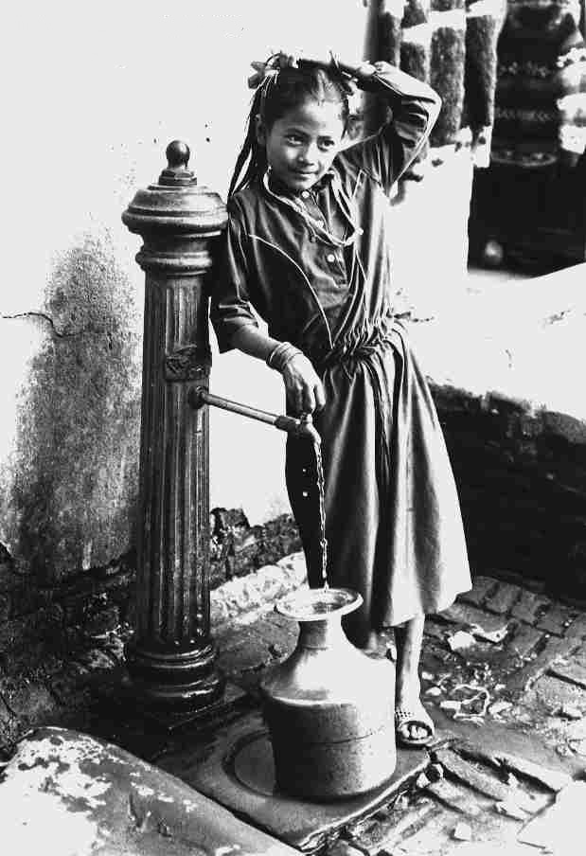
Improved water management has brought enormous benefits to people in developing countries. In the past 20 years, over 2.4 billion people have gained access to safe water supplies and 600 million to improved sanitation. Nevertheless, one in six people still has no regular access to safe drinking water.

More than twice that number (2.4 billion people) lack access to adequate sanitation facilities. Those without access to adequate sanitation are the poorest and most vulnerable. The problem is particularly severe in remote rural and rapidly growing urban areas.

Unsanitary water, which provides a breeding ground for parasites, amoebas and bacteria, damages the health of 1.2 billion people a year.

Water-borne diseases are responsible for 80 per cent of illnesses and deaths in the developing world, killing a child every eight seconds.

Half the world’s hospital beds are occupied by people suffering from water-borne diseases.

In southern Asia, between 1990 and 2000, 220 million people benefited from improved access to freshwater and sanitation. In the same period, the population grew by 222 million, wiping out the gains that had been made.

During the same period, in East Africa, the number of people without sanitation doubled to 19 million.

The cost of providing safe drinking water and proper sanitation to everyone in the world by 2025 will be US$180 billion a year, two to three times greater than present investments.

FRESHWATER IS ESSENTIAL FOR FOOD SECURITY
(Taken from: http://www.unep.org/wed/2003/keyfacts.htm)

Most of our freshwater is used to grow food. While the daily drinking water needs of every person is approximately four liters, between 2,000 and 5,000 liters of water are needed to produce an individual’s daily food requirements.

Agricultural water use accounts for over 75% of total global consumption, mainly through crop irrigation, (while industrial use accounts for about 20%, and the remaining 5% is used for domestic purposes.) It is estimated that between 14 and 17 per cent more water will be needed for irrigation by 2030 to feed the world’s growing population.

Sixty per cent of water used for irrigation is wasted because of inefficient irrigation techniques.

A 10 per cent improvement in irrigation efficiency could double the drinking water supply for the poor.

In Africa, more than 20 per cent of the population’s protein comes from freshwater fisheries.

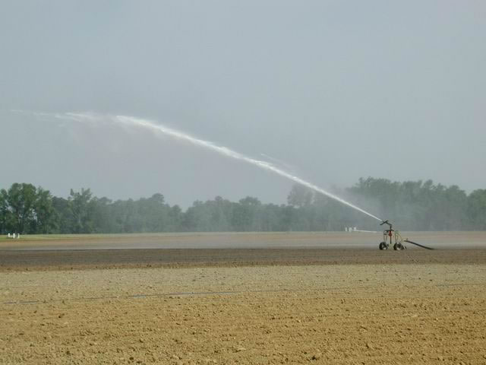

WATER IN THE FUTURE
(Taken from: http://www.unep.org/wed/2003/keyfacts.htm)

Two hundred scientists in 50 countries have identified water shortage as one of the two most worrying problems for the new millennium (the other was climate change).

Since 1950, global water use has more than tripled.

On current trends, over the next 20 years humans will use 40 per cent more water than they do now.

The number of people living in water-stressed countries is projected to climb from the current 470 million to three billion by 2025. Most of those people live in the developing world.

To achieve the 2015 targets for freshwater provision, water supplies will have to reach an additional 1.5 billion people in Africa, Asia, Latin America and the Caribbean.

Nearly 200 million people in Africa are facing serious water shortages. By 2025, nearly 230 million Africans will face water scarcity, and 460 million will be living in water-stressed countries. Water problems are more related to mismanagement than scarcity. Up to 50 per cent of urban water and 60 per cent of water used in agriculture is wasted through leaks and evaporation.

Logging and land conversion to accommodate human demand has shrunk the world’s forests by half, contributing to increased soil erosion and water scarcity. Between 300 and 400 million people worldwide live close to and depend on wetlands.

Wetlands act as highly efficient sewage treatment works, absorbing chemicals and filtering pollutants and sediments. Urban and industrial development has claimed half the world’s wetlands.

Sustainable development and poverty alleviation will only be achieved through better management of and investment in rivers and wetlands and the lands that drain into them.

MARINE WATER IS IN TROUBLE TOO
(taken from Vital Water Graphics, a UNDP report published 2003 http://www.unep.org/vitalwater/summary.htm)

A wide variety of human activities also affects the coastal and marine environment. Population pressures, increasing demands for space and resources, and poor economic performances can all undermine the sustainable use of our oceans and coastal areas. Serious problems affecting the quality and use of these ecosystems include:

1. Alteration and destruction of habitats and ecosystems. Estimates show that almost 50% of the world's coasts are threatened by development-related activities.

2. Severe eutrophication has been discovered in several enclosed or semi-enclosed seas. It is estimated that about 80% of marine pollution originates from land-based sources and activities.

3. In marine fisheries, most areas are producing significantly lower yields than in the past. Substantial increases are never again likely to be recorded for global fish catches. In contrast, inland and marine aquaculture production is increasing and now contributes 30% of the total global fish yield.

4. Impacts of climate change may include a significant rise in the level of the world's oceans. This will cause some low-lying coastal areas to become completely submerged, and increase human vulnerability in other areas. Because they are highly dependent upon marine resources, small island developing states (SIDS) are especially vulnerable, due to both the effects of sea level rise and to changes in marine ecosystems.

THE POLLUTION PROBLEM
(taken from: http://www.infoforhealth.org/pr/m14/m14chap4_1.shtml)

Pollution is pervasive. Few countries, whether developing or industrialized, have adequately safeguarded water quality and controlled water pollution. Many countries do not have standards to control water pollution adequately, while others cannot enforce water quality standards.

Increasingly, international development agencies are urging that developing countries devote more attention to protecting and improving water quality. The developed world also must spend more and do more to clean up degraded waterways, or economic development will stall and the quality of life will fall.

Agriculture is the biggest polluter, even more so than industries and municipalities. In virtually every country where agricultural fertilizers and pesticides are used, they have contaminated groundwater aquifers and surface waters. Animal wastes are another source of persistent pollution in some areas. The water that goes back into rivers and streams after being used for irrigation is often severely degraded by excess nutrients, salinity, pathogens, and sediments that often render it unfit for any further use, unless cleaned typically at great expense—by water purification plants.

In the US, agricultural chemicals, eroded sediment, and animal wastes have fouled over 173,000 miles of waterways. Farming is said to be responsible for 70% of current water pollution in the US. In India, which depends on irrigated agriculture for food supplies, more than 4 million hectares of high-quality land have been abandoned because of salinization and waterlogging caused by too much irrigation.

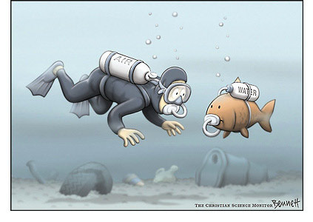
The world's tremendous output of pollutants challenges the capacity of waterways to assimilate or flush away pollution. A saying among water engineers is "the solution to pollution is dilution." This truism is taking on frightening dimensions. Each year roughly 450 cubic kilometers of waste water are discharged into rivers, streams, and lakes. To dilute and transport this dirty water before it can be used again, another 6,000 cubic kilometers of clean water are needed—an amount equal to about two-thirds of the world's total annual useable fresh water runoff. If current trends were to continue, the world's entire stable river flow would be needed just for pollutant transport and dilution by the middle of this century, according to an estimate by the UN Food and Agriculture Organization.

Industrialized countries. Europe and North America confront enormous water pollution problems. Over 90% of Europe's rivers have high nitrate concentrations, mostly from agrochemicals, and 5% of them have concentrations at least 200 times greater than nitrate levels naturally occurring in unpolluted rivers. In Poland three-quarters of the country's river water is too polluted even for industrial use.

Over half of Europe's lakes are eutrophied from a glut of agricultural and municipal nutrients. Eutrophication is a process that occurs when excess nutrients stimulate the growth of algae, which, when they die and decay, rob the water of oxygen. The numbers for the US are equally sobering….

Developing countries. Pollution is a vexing problem in countries where the population is growing rapidly, development demands are great, and governments have other investment priorities. In developing countries, on average, 90% to 95% of all domestic sewage and 75% of all industrial waste are discharged into surface waters without any treatment whatsoever. Consider these examples:

- All of India's 14 major rivers are badly polluted. Together they transport 50 million cubic meters of untreated sewage into India's coastal waters every year. The city of New Delhi dumps 200 million liters of raw sewage and 20 million liters of industrial wastes into the Yamuna River every day as the river passes through the city on its way to the Ganges.
- In Thailand and Malaysia water pollution is so heavy that rivers often contain 30 to 100 times more pathogens, heavy metals, and poisons from industry and agriculture than is permitted by government health standards.
- Over three-quarters of China's 50,000 kilometers of major rivers are so filled with pollution and sediment that they no longer support fish life. In 1992 China's industries discharged 36 billion metric tons of untreated or partially treated effluents into rivers, streams, and coastal waters.
- In greater São Paulo, Brazil, 300 metric tons of untreated effluents from 1,200 industries are dumped into the Tiete River every day as it flows through the city. As a result, the river contains high concentrations of lead, cadmium, and other heavy metals. The city also dumps some 1,000 metric tons of sewage into the river each day, of which only 12% gets any treatment whatsoever.

Industrial and municipal pollutants. While agriculture remains the biggest source of water pollution, wastes from industries and municipalities have increased enormously in recent decades. Between 200 and 400 major chemicals are estimated to contaminate the world's rivers. Industrial pollutants, such as wastes from chemical plants, are often dumped directly into waterways. Oils and salts are washed off city streets. Heavy metals and organochlorines are leached from municipal and industrial dump sites.

Furthermore, pollutants such as sulfur dioxide and oxides of nitrogen, which combine in the atmosphere to form acid rain, have had pervasive effects on both freshwater and land ecosystems. Acid rain lowers the pH of rivers and streams. Unless buffered by calcium (as contained in limestone), acidified waters kill many acid-sensitive fish, including salmon and trout. In the soil, acids can release heavy metals, such as lead, mercury, and cadmium, that then percolate into waterways.

Some of the worst pollutants are synthetic chemicals. Some 70,000 different chemical substances are in regular use throughout the world. Every year an estimated 1,000 new compounds are introduced. Many of them find their way into rivers, lakes, and groundwater aquifers. In the US alone, more than 700 chemicals have been detected in drinking water, 129 of them considered highly toxic.

A number of synthetic chemicals, particularly the group known as persistent organic pollutants (POPs), which includes halogenated hydrocarbons, dioxins, and organochlorines such as DDT and PCBs, are long-lived and highly toxic in the environment. They do not break down easily under natural processes and thus tend to accumulate up the biological food chain, until they pose risks to human health. For example, Beluga whales swimming in the highly polluted St. Lawrence River, which connects the Atlantic Ocean to North America's Great Lakes, have such high levels of PCBs in their blubber that, under Canadian law, they now qualify as "toxic waste dumps". Indigenous communities that once hunted these whales no longer are permitted to take any because of the health risks.

US Water Facts

Groundwater depletion (Taken from Ground-Water Depletion Across the Nation
U.S Geological Survey Fact Sheet 103-03, 2003; http://water.usgs.gov/pubs/fs/fs-103-03/)

Ground-water use has many societal benefits. It is the source of drinking water for about half the nation and nearly all of the rural population, and it provides over 50 billion gallons per day in support of the Nation’s agricultural economy. Ground-water depletion, a term often defined as long-term water-level declines caused by sustained ground-water pumping, is a key issue associated with ground-water use. Many areas of the United States are experiencing ground-water depletion.

What are some effects of groundwater depletion?
If intensive pumping from an aquifer continues, then adverse effects may occur.
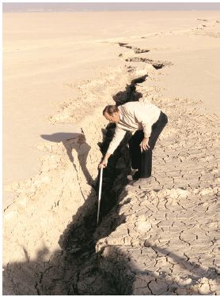
Deterioration of water quality Coastal aquifers tend to have wedgeshaped zones of saltwater underlying the potable freshwater. Under natural conditions the boundary between the freshwater and saltwater tends to be relatively stable, but pumping can cause saltwater to migrate inland, resulting in saltwater contamination of the water supply. Inland aquifers can experience similar problems where withdrawal of good-quality water from the upper parts of inland aquifers can allow underlying saline water to move upward and degrade water quality. Additionally, where ground water is pumped from an aquifer, surface water of poor or differing quality may be drawn into the aquifer. This can degrade the water quality of the aquifer directly or mobilize naturally occurring contaminants in the aquifer.

Subsidence Land subsidence is “a gradual settling or sudden sinking of the Earth’s surface owing to subsurface movement of earth materials.”

This earth fissure formed on Rogers Lake at Edwards Air Force Base, California, in January 1991, and forced the closure of one of the space shuttle’s alternative runways. The fissure has been attributed to land subsidence related to ground-water pumping in the Antelope Valley area.

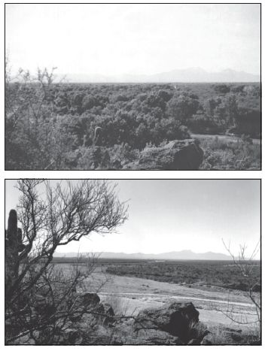 | Reduced surface-water flows  A related effect of ground-water pumping is the lowering of ground-water levels below the depth that streamside or wetland vegetation needs to survive. The overall effect is a loss of riparian vegetation and wildlife habitat.  A 1942 photograph (top) of a reach of the Santa Cruz River south of Tucson, Arizona, shows stands of mesquite and cottonwood trees along the river. A photograph (bottom) of the same site in 1989 shows that the riparian trees have largely disappeared, as a result of lowered ground-water levels. Photos: Robert H. Webb, USGS.  (taken from http://water.usgs.gov/pubs/fs/fs-103-03/

Agriculture is the culprit!
Agricultural and industrial water consumption (87%) dwarfs that of the domestic sector (13%) in the U.S. Since a significant chunk of agricultural water goes to meat production, the clearest single way for us individuals to save the most water may be to eat less meat and consider the water requirements of other products we consume (e.g. paper). (taken from http://www.newdream.org/monthly/aug00.html)

Meat
Producing a single pound of feedlot beef requires 445 to 12,000 gallons of water. The average is about 2400 gallons of water per pound of beef. "Feedlot" means cattle is kept in close quarters and fed with a specially produced feed (in other words, the cattle is not grazing). (taken from http://www.newdream.org/monthly/oct99.html)

We are water hogs!
Water consumption in the domestic sector, albeit small relative to agricultural and industrial consumption, is no piddling amount - the average North American consumes over 170 gallons per day, more than seven times the per capita average in the rest of the world and nearly triple Europe's level. By comparison, the World Health Organization says good health and cleanliness require a total daily supply of about 8 gallons of water per person. (taken from http://www.newdream.org/monthly/aug00.html)

More info:
Gary Gardner, "Preserving Agricultural Resources" State of the World 1996, Worldwatch Institute, 1996. Alan Durning and Holly Brough, "Taking Stock: Animal Farming and the Environment" Worldwatch Institute, 1991. J.L. Beckett and J.W. Oltjen "Estimation of the Water Requirement for Beef Production in the United States" Journal of Animal Science 71 (1993)
D. Pimentel et.al. "Water Resources: Agriculture, the Environment and Society: An Assessment of the Status of Water Resources" BioScience (Feb. 1997).

How do we use water?
Water generally gets to where people live in one of two ways. Either it’s delivered by a city/county water department (a municipality) or maybe from a private company, or it comes from a private supply, normally from a well. (taken from http://ga.water.usgs.gov/edu/wudo.html)

At Tufts, the water comes from the towns of Medford and Somerville. Almost all the water that is used in the Metro Boston Area comes from the Quabbin Reservoir out in Western Massachusetts.

The USA ranks dead last among the 29 OECD nations. In other words, we consume more water per capita than any other developed country. (OECD stands for Organisation for Economic Co-operation and Development: find out more at www.oecd.org)
(source: http://www.environmentalindicators.com/htdocs/indicators/6wate.htm)

Total US water withdrawals by category in 2000
.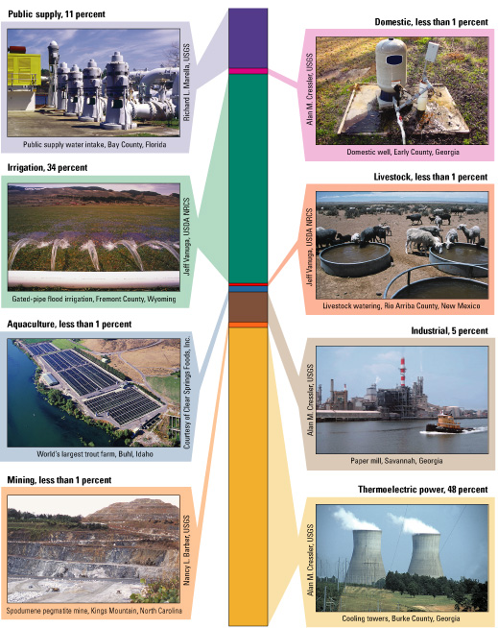
(Source: http://water.usgs.gov/pubs/circ/2004/circ1268/htdocs/figure01.html)
Electricity production is responsible for almost half of all fresh water withdrawal. This water is used for cooling in power plants and either evaporates in a cooling tower (see picture) or is fed back into the body of water. That sounds harmless but literally millions of fish and other fauna are killed during the intake of the water. The ‘waste’ water is clean but several degrees warmer. That impacts local ecosystems. That is why:

Conserving electricity also saves water!

Trends in population and freshwater withdrawals by source, 1950-2000.
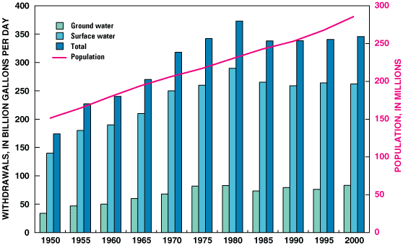
(http://water.usgs.gov/pubs/circ/2004/circ1268/htdocs/figure13.html)

How do you use water at home?
What is your personal water usage like on a typical day? Think about direct consumption (drinking, washing, toilet, etc.) and about the water used to make other things that you use (look at the irrigation part of the chart on the previous page, and think about the food that you eat; has any of it been irrigated? Look at the power generation slice of the pie below; how much water has been used to generate the power you used today?)
How many gallons do you think you personally use each day? Take a guess and keep reading!
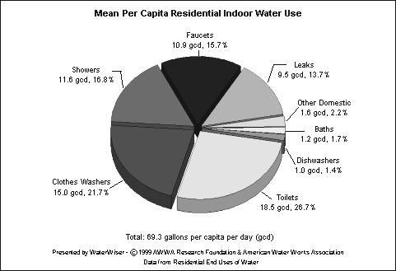
This graph does not show water used for lawns and gardens. In New England, this can account for more than 50% of the water use in a household, especially in the summer.

This graph does only shows househols use of H2O. If you factor in indirect water use (e.g. from consuming food, electricity, paper, etc. Per capita use in the US is 120-170 gallons a day.

Each person uses an average of 120-170 gallons
of water per day!
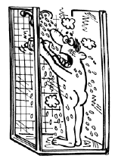
Learn more at: http://www.h2ouse.org/

Local Water Facts

The Mystic River Watershed
(taken from: http://www.mysticriver.org/)

The Tufts Medford Campus lies within the Mystic River Watershed. The Mystic River Watershed has an area of approximately 76 square miles, encompassing 21 communities north and west of Boston, Massachusetts. The headwaters of the system begin in Reading and end in the Boston Harbor. Main tributaries to the Mystic River include Mill Brook, Alewife Brook, Malden River, and Chelsea Creek. The watershed contains 44 lakes and ponds, the largest of which is Spot Pond in the Middlesex Fells, with an area of 307 acres.

Home to about 8% of the state's population (nearly half a million people) in less than 1% of its land area, the Mystic is one of the most densely populated and urban watersheds in Massachusetts. Eight out of the fifteen Massachusetts communities "most intensively overburdened" by cumulative environmental hazards lie within this watershed, according to recent environmental justice research.

The name “Mystic” is derived from the Indian “Missi-Tuk” or “great tidal river,” a reference to the Mystic having once been tidal. For hundreds of years, Native Americans lived and fished along the Mystic. One of the Mystic area’s first European settlers was Massachusetts Bay Colony Governor John Winthrop. He built his summer retreat, the Ten Hills Farm, on the banks of the Mystic.

Both Native Americans, and later Colonists, used weirs to catch alewives and fertilize their crops. During the 1800s, factories replaced many farms, and the region attracted many new residents. By 1865, overfishing and pollution all but eliminated commercial fishing.

From early Colonial days until the end of the 19th century, the waters of the Mystic were harnessed to power tide mills. Tide mills were built throughout the length of the Mystic on both sides of the shore. Their waterpower was used to grind grain and spices, saw wood, and process paints, cloth and other products. Mills, brickyards and tanneries along the river brought wealth, but some industries also polluted the Mystic watershed. Today, a mix of houses, businesses, parks and abandoned factories border the River.

Twice each day, tides once influenced the waters of the Mystic, Malden, and Alewife Brook. First the Craddock Locks, 1909, and later, the Amelia Earhart Dam, 1966, changed these waterbodies from salt to freshwater. In the 1960s, construction of I-93 filled in wetlands and dramatically changed the Mystic River’s course.

Pollution
Sadly, there are numerous ways in which the waters of the Mystic and its tributaries are polluted. There are toxics in the water and sediment as a result of industry in the area. There are also problems normally associated with older urban areas: non-point source pollution and sewage contamination.

Non-point source (NPS) pollution refers to pollution that does not come from a specific, easily-identifiable source, such as a pipe or smokestack. In terms of water quality, NPS pollution usually occurs as urban runoff. In our watershed, only 17% is designated as open space, and in Somerville, 85% of the land is impermeable! Therefore, urban runoff is a substantial problem!
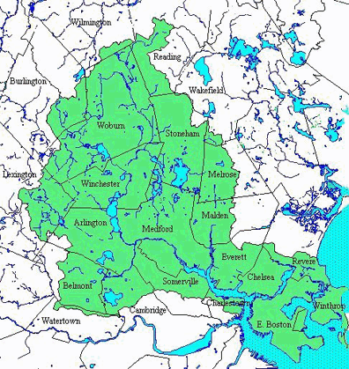
Sewage and infrastructure are also major problems throughout the watershed. Some of the sewer and storm drain pipes are greater than 70 years old, and thus very leaky. Sewage filters out of the sewer lines in to the storm drains, which discharge directly local streams, ponds, and rivers.

In addition to leaky pipes, there are also numerous Combined Sewer Overflows (CSOs) in our watershed. While modern systems generally handle rainwater and sewage from homes and businesses in different pipes, older systems in Boston, Cambridge, Chelsea and Somerville have 'combined' sewers that carry both flows together. Combined storm and sanitary sewers carry both raw sewage from residences and industrial sites as well as contaminated runoff from city streets. In dry weather, combined systems generally carry sewage wastes to wastewater treatment plants. When it rains, at times as little as one-quarter inch, the volume of the combined wastewater becomes more than the treatment can handle, and the flow is diverted to outfall points that discharge raw sewage, floatables such as garbage, syringes, and tampon applicators, toxic industrial waste, and contaminated stormwater into the nearest stream or coastal waterway. These untreated discharges can be as potent as direct sewer emissions. They are a principal cause of shellfish bed closures, beach advisories, pathogen contamination, odor and other aesthetic problems in many cities with combined sewer systems.
(taken from: http://www.cwn.org/docs/issues/rawsewage/cso.htm)

What You Can Do To Save Water

Eat less meat!!
Use less electricity!
Use less paper!

How to Save Water in the Bathroom
(Modified from Massachusetts Water Resources Authority: http://mwra.state.ma.us/04water/html/watersav.html)

Turn off the tap while brushing your teeth or shaving. Save 4-10 gallons a day.

Don't shave with the water running.
You'll probably use at least one gallon per minute, most of it wasted. A stoppered basin needs one-half gallon or so of water for adequate razor rinsing.

Never use your toilet as a trashcan. Save 3-7 gallons per flush. Stop using the toilet as an ashtray or wastebasket. Some people flush away tissues and other bits of trash in the toilet. Using a wastebasket will save all those gallons of water that otherwise go wastefully down the drain.

Most toilets installed before 1980 use 5-7 gallons of water per flush. Toilets installed between 1980 and 1993 use 3.5 gallons per flush. Toilets installed since 1994 use 1.6 gallons. All new toilets at Tufts are low flow toilets.

Fill your bathtub only partially. Save 5 gallons or more. Saves in hot water costs, too.
A typical bath takes about 40 gallons of water. Use the minimum amount of water needed for a bath by closing the drain first and filling the tub only 1/3 full. Remember to plug the tub before turning on water; that initial burst of cold water will be warmed later by adding hot water.

Don't take marathon showers. Five minutes will get you clean. Save 3-7 gallons per minute.
Limit the length of your shower to 5 minutes or less. Reducing showering time by 1 minute can save 2,000 gallons of water a year.

What You Can Do: In The Kitchen And Laundry Areas
(Modified from Massachusetts Water Resources Authority: http://mwra.state.ma.us/04water/html/watersav.html)

If you wash dishes by hand, don’t leave the water running for rinsing.

Tufts and Water
Tufts has installed low-flow toilets and showerheads throughout the campus.

Tufts is in the process of switching to front-loading washing machines. These save 50% of the water a top loader uses (see next box).

If you have two sinks, fill one with soapy water and one with rinse water. If you have only one sink, gather washed dishes in a dish rack and rinse them with a sprayer or a pan full of hot water. Saves 8-15 gallons per day. Saves in hot water costs, too.

Run your dishwasher only when full.
Save up to 15 gallons per load. Saves in hot water costs, too. Fill your dishwasher full because it will use the same amount of water for a normal cycle, whether it contains a full load of dishes or just a few items. Also, there’s really no need to fully wash dishes before loading in the dishwasher. Just scrape the food off and let the dishwasher do the rest of the work.

Wash vegetables and fruit in a basin. Use a vegetable brush to remove dirt. Save 2-4 gallons per day.

Run your garbage disposal only when necessary. Save 2-7 gallons per minute.

Run the washing machine only when full and adjust the water level setting carefully. Washing machines use 22-25 gallons per load. Save the water for 1-2 loads every week. Saves in hot water costs, too.

Store drinking water in the refrigerator rather than letting the tap run, when you want a cold glass of water. Did you know that you could refill an 8-oz. glass of water approximately 15,000 times for the same cost as a six-pack of soda?

Do not use running water to thaw meat or other frozen foods. Defrost food overnight in the refrigerator. This will actually save energy because the cold emitted from the frozen food will help cool your fridge . Do not defrost in your microwave or toaster oven. This wastes energy unnecessarily.
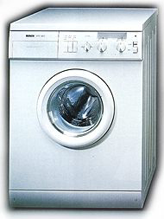

Front-loading Washing Machines

Most washing machines are energy and water hogs simply because of their design: they are loaded from the top and fill up with water completely.

Front-loading washing machines use about 50 to 70% less water and 30 to 50% less energy than top loaders because water only fills up to about 1/3. Front loaders also reduce drying time considerably because they wring clothes more thoroughly. This saves additional energy.

Tufts has replaced 100 of its 124 washing machines with front loaders. Each front loader at Tufts saves about 17,000 gallons of water per year.

How To Find Leaks
Dripping, trickling, or oozing faucets and showerheads can waste from 75 to several hundred gallons of water a week depending on the size of the drip. Worn out washers (rubber rings in the pipes, not washing machines) are the main cause of these leaks and a new one generally costs about 25 cents.
Little leaks add up in a hurry! A faucet drip or invisible toilet leak that totals only two tablespoons a minute comes to 15 gallons a day. That’s 105 gallons a week or 5,460 wasted gallons of water a year.

A Simple Test for Leaks
A leaky faucet is pretty obvious. But hidden leaks in the toilet, under the sink, or behind a washing machine can waste a gigantic amount of water. And they could be damaging your floors or ceilings too. At your home, you can take a reading of your water meter. Wait an hour, making sure no one uses any water in your home. Check it again. If the reading has changed, you have got at least one leak and you need to investigate.

Toilet leaks
That trickling sound you hear in the bathroom could be a leaky toilet wasting 50 gallons of water a day or more. But sometimes it leaks silently. Try this:

Crush a dye tablet in its envelope and carefully empty the contents into the center of the toilet tank and allow it to dissolve. Wait about 8-9 minutes. Inspect the toilet bowl for signs of blue dye indicating a leak.

If the dye has appeared in the bowl, the flapper or flush valve may need to be replaced.

If you find a leak at Tufts, call work control at 7-3496.

Bottled or not?

Check out the report by the Natural Resources Defense Council, Bottled Water: Pure Drink or Pure Hype? at www.nrdc.org/water/drinking/nbw.asp, March 1999, for more information. This report revealed that much too often, bottled water is of poorer quality (has more germs) than tap water.

Think about your drinking water. Do you buy a lot of bottled water even though you have good tap water or water from a cooler in your dorm? If so, maybe it makes more sense to get a water bottle, refill it, and carry it with you. Do you recycle the plastic bottles that the water comes in?

1.5 million tons of plastic are used to make bottles for bottled water per year. What is the environmental impact of this packaging?

About a quarter of the 25 billion gallons of annual production of bottled water is consumed outside the country of origin. Over 22 million tons of water is therefore being moved each year from country to country in plastic bottles, with consequent implications for energy consumption and emissions associated with transportation. (World Wildlife Fund, May 2001 http://www.panda.org/downloads/bottled-water.pdf)

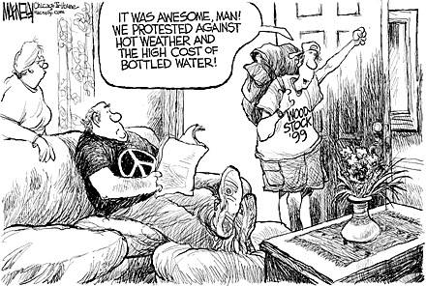

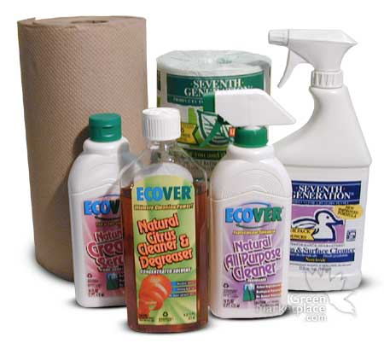

Green Cleaning: Simple Solutions

When it comes to cleaning up the planet, there’s no place like home to start taking a look at what each individual can do. Take a look at how you can make simple cleaning solutions from common ingredients, how to evaluate the labels of ready-made cleaners, recommendations on specific cleaners for different tasks, and where to find more information.

What Should I Look For When I Buy Cleaners?
(taken from: http://www.ehow.com/how_110332_buy-green-household.html)

Read the label. Choose non-petroleum-based surfactants that are chlorine and phosphate free, (hint: if they don’t say ‘petroleum-free’, they are not…) claim to be non-toxic, and are biodegradable. Read the labels of cleaners and look for these four key signal words—caution, warning, danger, poison— which indicate the level of hazard. Use the least hazardous product to do the job. ("Caution" is least hazardous and "danger" is most hazardous. Extremely toxic products must also include the word "poison.")

Avoid the most toxic elements: ammonia and chlorine. Often found in scouring powders, laundry bleach, dishwasher detergent, and basin, tub, and tile cleaners, these chemicals are a prime cause of health problems and environmental pollution. Ammonia is also an irritant that affects the skin, eyes, and respiratory passages. The symptoms of ammonia exposure are: burning sensation in the eyes, nose, and throat; pain in the lungs; headache; nausea; coughing and increased breathing rate.

Chlorine is the household chemical most frequently involved in household poisoning in the U.S. Chlorine also ranks first in causing industrial injuries and deaths resulting from large industrial accidents. Chlorine is an acutely toxic chemical.

Avoid those really strong oven cleaners. Rule of thumb: the more miraculously it cleans, the more toxic it is.

Don't use toilet bowl fresheners and don't disinfect your toilet bowl (it's unnecessary to disinfect the inside of your toilet). (oh, and don’t use disposable toilet brushes either…)

Look for:
'100% bio-degradable' and 'non-toxic'
Make Your Own Non-Toxic Cleaners!
Here are some basic (and inexpensive) ingredients for cleaners you can get at the grocery store and what they clean:
White Vinegar (don’t use red wine vinegar or cider vinegar!): Mix with water, and you have a great window and glass cleaner. Use vinegar on porcelain, countertops, and tile.
Baking Soda: This can also be used as an all-purpose cleaner. Just mix with water. Use especially for scouring sinks and tubs. Sprinkle over carpet as a deodorizer.
Salt: Use for deodorizing drains and garbage disposals. Salt can also be used as an abrasive in cleaning pots and pans.
Lemon Juice: Use as a bleach in laundry and on kitchen surfaces. It adds a fresh clean smell to cleaners.
Cornstarch: Sprinkle on carpet as a deodorizer. Mix with water and use a spray bottle for laundry starch.
Olive oil: Mix with vinegar for use as a furniture polish.
Any of these ingredients can be safely mixed together. Experiment to find out what works best for each cleaning need. Store mixtures in spray bottles, and remember to clearly label them for future use. Maybe you can share cleaning products with your dorm mates too. Check out what kind of cleaners you find at home. Talk to your family about what they use, and see if any of these simpler solutions could replace a toxic cleaner.

Natural Homemade Cleaners and Chemical Replacers
(taken from http://www.geocities.com/Heartland/Hills/9684/fabric.html)

Hard Water Fabric Gel Soap

2 cups pure soap flakes

1 1/2 cups Borax

6 cups warm water

1/2 cup glycerin

2 teaspoons essential oil of either lavender, lemon or eucalyptus
1) In a medium saucepan, stir together the soap flakes, borax, and water. Heat slowly and stir until the mixture is clear. Add the glycerin and set aside to cool.
2) When cool, add the essential oil and stir thoroughly.
3) Pour into a mason jar or other container and cover until needed. To use, add 1 cup of Gel per load of clothes, making sure the soap is dissolved well before adding clothes to the water. This gel works best with warm water, or dissolve it in a quart of warm water before adding it to the wash water.
~~~~~~~~~~~~~~~~~~~~~~~~~~~~~~~~~~~~~~~~~~~~~~~~~~~~~~~~~~~~~

Fabric Softener
• 1/4 cup baking soda
• 1/2 cup white vinegar
1) Fill the washing machine or basin with water
2) Add the baking soda, stir it around to dissolve, then add the clothes.
3) After rinsing the clothes, make a final rinse and add the vinegar to it.
Another way to soften clothes is to add 1/2 cup baking soda to the wash water, or use 1 part soap flakes and 1 part borax in the wash water before you add the clothes.

All-Purpose Cleaner and Disinfectant
• 1 teaspoon borax
• 1/2 teaspoon washing soda
• 2 Tablespoons lemon juice
1) In a spray bottle that will hold at least a pint, combine the ingredients. Add 1 cup very hot water and shake well, mixing and dissolving the dry ingredients.
2) To use, simply spray and wipe. This can be stored indefinitely.
~~~~~~~~~~~~~~~~~~~~~~~~~~~~~~~~~~~~~~~~~~~~~~~~~~~~

Non-Streaking Spray Glass Cleaner
• 1/4 cup white vinegar
• 1 Tablespoon cornstarch
• 2 cups warm water
Put all ingredients in a large spray bottle. Shake well to dissolve the cornstarch. To use, spray liberally on the glass, wipe with a clean cloth. Buff to a streak free shine with a wadded up piece of newspaper.
~~~~~~~~~~~~~~~~~~~~~~~~~~~~~~~~~~~~~~~~~~~~~~~~~~~~~~~~~~~~~~~~

Septic Toilet Activator

Use this if there is a persistant odor from the septic tank and indications that the sewage digesting bacteria are not present in sufficient numbers

• 1 quart hot water
• 1 pound brown sugar
• 2 teaspoonsdried yeast
Dissolve the brown sugar in hot water and leave til it is luke-warm. Stir in the yeast, and immediately flush the mixture down the toilet. Do this last thing at night when there is not as much activity in the bathroom.
~~~~~~~~~~~~~~~~~~~~~~~~~~~~~~~~~~~~~~~~~~~~~~~~~~~~

Automatic Dishwasher Soap
• 2 cups borax
• 2 cups washing soda
Mix the washing soda and the borax and store in a plastic covered container. To use, add 2 tablespoons to the dishwasher soap compartment. If you have hard water, you may want to use the Spotless Dishwasher Rinse, below.
~~~~~~~~~~~~~~~~~~~~~~~~~~~~~~~~~~~~~~~~~~~~~~~~~~~~~~~

Spotless Dishwasher Rinse
1 to 1 1/2 cups white vinegar added to the rinse compartment of your dishwasher will do! Don't overfill. Add before washing.
~~~~~~~~~~~~~~~~~~~~~~~~~~~~~~~~~~~~~~~~~~~~~~~~~~~~~~~~~~~~

Dishwashing Liquid

This inexpensive soap does not suds up very much, but it cleans so well! Use with hot water. Do not use it in automatic dishwashers.

1/4 cup soap flakes

2 cups hot water

1/4 cup glycerin

1/2 teaspoon lemon essential oil
1) In bowl combine soap flakes and water and stir until the soap is dissolved. Cool to luke warm.
2) Stir in the glycerin and the essential oil, leave to cool. As it cools it will form a loose gel. Stir with a fork and break up the gel and then pour into a narrow-necked bottle. An old shampoo bottle makes an excellent container.
3) To use, squirt 3 teaspoonfuls into hot running water.
~~~~~~~~~~~~~~~~~~~~~~~~~~~~~~~~~~~~~~~~~~~~~~~~~~~~~~~~~

Non-Toxic Toilet Bowl Cleaner
• 1 cup borax
• 1/2 cup white vinegar
1) Flush the toilet to wet the sides. Sprinkle the borax all along the sides of the inside of the bowl.
2) Drizzle the vinegar over the borax and leave over night.
3) Next day, scrub with a toilet brush and flush.
~~~~~~~~~~~~~~~~~~~~~~~~~~~~~~~~~~~~~~~~~~~~~~~~~~~~~~~~~

Oven Cleaner
• 1 box baking soda (16 0zs.)
• 1/4 cup washing soda
1) In a container mix the ingredients well.
2) Wet the floor and walls of the oven using a rag or paper towels.
3) Generously sprinkle the walls and floor with the mixture. Repeat and allow to sit over night.
4) In the morning, wipe all the grease and film away using an old rag. Rinse well.
5) Stubborn stains may have to be scrubbed with an abrasive pad and some salt.
~~~~~~~~~~~~~~~~~~~~~~~~~~~~~~~~~~~~~~~~~~~~~~~~~~~~~~~~~~

Lemony Furniture Oil
• 1 cup olive oil or vegetable oil
• 1 teaspoon lemon essential oil
Mix well. Apply with a soft rag. Wipe and buff well to a gleaming shine.

